Contents

CLOUD COMPUTING 3

IP ADDESSS 3

CLOUD CONCEPTS 5

WHAT IS CLOUD COMPUTING 5

BENEFITTS OF CLOUD 5

HIGH AVAILABILITY 5

TYPES OF CLOUD 5

VIRTUALIZATION 6

HYPERVISOR 6

BENEFITS OF VIRTUALIZATION 6

AZURE 6

HOW AZURE WORKS? 6

RESOURCE GROUP 6

CREATING A RESOURCE GROUP 7

REGION AND ZONES 7

SELECTING A REGION 8

AZURE COMPUTE SERVICES 8

VIRTUAL MACHINE 8

AZURE’S VIRTUAL MACHINE SERVICE 9

AZURE VIRTUAL MACHINE – KEY CONCEPTS 9

DEPLOYING A VIRTUAL MACHINE 9

DEPLOYING WINDOWS VM 10

DEPLOYING LINUX VM 15

INSTALLING SOFTWARES IN VM 16

QUOTA OF VM 17

AZURE MARKET PLACE 18

AVAILABILITY 19

INCREASING THE AVAILABILITY 19

AVAILABILITY SETS 19

AVAILABILITY ZONES 23

NOTES ON AVAILABILITY ZONES AND SET 24

VIRTUAL MACHINE SCALE SETS 24

AZURE DEDICATED HOST 25

AZURE SPOT INSTANCES 26

WORKLOAD 26

IMPORTANT USE CASES AND SOLUTIONS 27

AZURE VIRTUAL NETWORK 27

CREATING A VIRTUAL NETWORK 27

CREATING A SUBNET IN VIRTUAL NETWORK 29

CREATING A VIRTUAL MACHINE IN VIRTUAL NETWORK 29

COMMUNICATION ACROSS VIRTUAL MACHINES IN A VIRTUAL NETWORK 30

NETWORK SECURITY GROUP 30

APPLICATION SECURITY GROUP 31

NETWORK CONNECTIVITY OPTIONS 32

VIRTUAL NETWORK PEERING 32

SITE-TO-SITE VPN CONNECTION 32

POINT-TO-SITE VPN CONNECTION 33

AZURE EXPRESS ROUTE 33

AZURE CORE SERVICES 34

AZURE STORAGE 34

CREATING A STORAGE ACCOUNT (GENERAL PURPOSE V2 STORAGE ACCOUNT) 34

STORAGE ACCOUNT 35

DATA REDUNDANCY IN AZURE STORAGE ACCOUNT 35

CORE STORAGE SERVICES 38

AZURE WEB-APP SERVICE 44

ADVANTAGE OF USING APP SERVICE 45

CREATING AN APP SERVICE 45

AZURE APP SERVICE PLAN 46

VIRTUAL MACHINE SCALE SET 47

SCALLING IN VM SCALE SET 47

CREATING A VM SCALE SET 48

AZURE LOAD BALANCER 48

COMPONENTS OF LOAD BALANCER 49

BASIC LOAD BALANCER 49

STANDARD LOAD BALANCER 49

# CLOUD COMPUTING

## IP ADDESSS

* IP is the unique identifier of a device in a network.



|  |  |
| --- | --- |
|  | * The IP address has 2 parts – The Network part and a Host part. * Each host in a network will have same Network Address |

#### IPv4 ADDRESSING

* It’s a 32-bit logical address
* It consists of 4 octet – and each octet ranges from 0 -255
* IP address has parts ***Network ID and Host ID***



#### BINARY TO DECIMAL



* When the IP is represented in Binary the decimal representation can be done using the ***power to 2***
* Hence the equivalent decimal will be 192.168.100.1 (128+64).(128 + 32 +8).(64+32+4).(1)

#### CLASSES IN IP ADDRESSING



* Ranges 127.x.x.x are reserved for the [loopback or localhost](https://www.computerhope.com/jargon/l/locahost.htm), for example, 127.0.0.1 is the loopback address.
* Range 255.255.255.255 [broadcasts](https://www.computerhope.com/jargon/b/broadcas.htm) to all hosts on the local network.

1. HOW TO DECIDE THE CLASS OF IP ADDRESS?

To decide the class of IP address we consider the first octet for example – **132**.20.10.192 – This IP belong to CLASS B.

#### NETWORK ID IN IP ADDRESSING

|  |  |
| --- | --- |
|  | * In Class A IP address 1st 8 bits are Network Id * Remaining 24 bits are for Host hence for class a we can have * Hence number of Host is **224 = 16777216** |
| * In Class B IP address 1st IP 16 bits are Network Id * Remaining 16 bits are for Host hence for class a we can have * Hence number of Host is **216 = 65536** |
| * In Class C IP address 1st IP 24 bits are Network Id * Remaining 8 bits are for Host hence for class a we can have * Hence number of Host is **216 = 256** |

* Example : Find the network id of IP : **192.10.10.10** ?
  + Step 1 : The class of this IP is Class C
  + Step 2: The class B IP has first 24 bit (1st 3 Octet) as its network id . Hence the Network id : **192.10.10.0**

#### SUBNET, SUBNET MASK AND CIDR NOTATION

* Note the network id is represent by “1” and host is represented by “2”.

##### CALCULATING SUBNET MASK

* Example : Calculate the Subnet mask of : **115.10.10.20 ? Ans – 255.0.0.0**

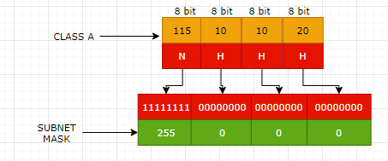

###### WHAT IS THE JOB OF SUBNET MASK?

* Since the IP is consist of 2 part Network and Host part. Network Part in a network will be same for all host.
* Host decide the network Id with the help of Subnet Mask.
* Subnet mask is also of 32 bits -which has a mapping with the IP address. The 1s represent the network portion and 0s are the host portion. In the above example – When an IP is given to a device – then the subnet mask is also configured. The bits represented with “1” is the network id in the IP – when compared from left to right.

##### BROADCAST ID

* Broadcast IP is used to broadcast to all the host in the network.
* Find the class, network id ,broadcast id and usable IP of the following IP

|  |  |
| --- | --- |
| 150.10.20.30 | * The IP belongs to Class B * Network Id: 150.10.0.0 * Broadcast ID: To calculate the broadcast id, set the host part of Network to 255. Hence the broadcast Id - 150.10.255.255 * Usable Host IP = Total Number of IP address – (Network IP + Broadcast IP) i.e.   + For a network there will be on Network IP and one Broadcast IP.   + Usable Host IP = Total IP -2= 216 – 2 = 65536 – 2= **65534** |

###### CIDR NOTATION (CLASSLESS INTER DOMAIN ROUTING)

* In class world we use subnet mask to deduce the number of bits used for Network
* Similarly, rather than using the subnet mask - CIDR notation is a way to represent the network.
* For example, **192.168.100.1/24**
  + This represent that the first 24 bits are used for network id. It is also called network pre-fix

# CLOUD CONCEPTS

## WHAT IS CLOUD COMPUTING

1. **It's the delivery of computing services over the internet, which is otherwise known as the cloud.** These services include **servers, storage, databases, networking, software, analytics, and intelligence.** Cloud computing offers faster innovation, flexible resources, and economies of scale.
2. Cloud computing is the delivery of computing services over the internet by using a pay-as-you-go pricing model. You typically pay only for the cloud services you use, which helps you:

* Lower your operating costs.
* Run your infrastructure more efficiently.
* Scale as your business needs change.

To put it another way, cloud computing is a way to rent compute power and storage from someone else's datacenter. You can treat cloud resources like you would resources in your own datacenter. When you're done using them, you give them back. You're billed only for what you use. Instead of maintaining CPUs and storage in your datacenter, you rent them for the time that you need them. The cloud provider takes care of maintaining the underlying infrastructure for you.

## BENEFITTS OF CLOUD

1. High Availability
2. Scalability
3. Disaster Recovery
4. Elasticity
5. Fault Tolerance.

### HIGH AVAILABILITY

## TYPES OF CLOUD

* Public :
* Private :
* Hybrid :
* Community:

## VIRTUALIZATION

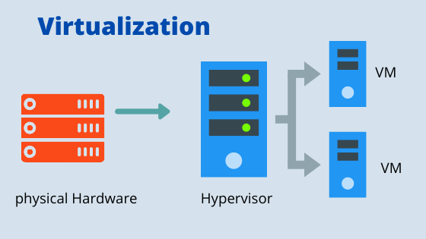

* Virtualization is the process of running a virtual instance of a computer system in a layer abstracted from the actual hardware. Most commonly, it refers to running multiple operating systems on a computer system simultaneously.
* To the applications running on top of the virtualized machine, it can appear as if they are on their own dedicated machine, where the operating system, libraries, and other programs are unique to the guest virtualized system and unconnected to the host operating system which sits below it.

Note : The machine on which VM are created are called HOST MACHINE and all the VM are called GUUEST MACHINE.

* For administrators of servers, virtualization also offers the ability to run different operating systems, but perhaps, more importantly, it offers a way to segment a large system into many smaller parts, allowing the server to be used more efficiently by a number of different users or applications with different needs. It also allows for isolation, keeping programs running inside of a virtual machine safe from the processes taking place in another virtual machine on the same host.

### HYPERVISOR

* Hypervisor is a software which creates and run the VM on a host machine.

### BENEFITS OF VIRTUALIZATION

* Better resource utilization
* Lowers the cost of resources
* Enable Remote Access
* Pay as you go
* Enable running multiple OS

# AZURE

## HOW AZURE WORKS?

# RESOURCE GROUP

* Resource Group can be considered as a logical container/separation of resources. For example – For an organization resource group can be separated based resources a of an organization is using.
* Every resource we create in Azure platform must be a part of resource group.
* There is no cost involved in creation of resource group.

## CREATING A RESOURCE GROUP

|  |  |
| --- | --- |
| * All the resources are tied to a subscription for billing aspects. * The resource group must associate to a region. * ***A resource cannot be a part of two different resource group*** * ***The resource can only be a part of a one subscription.*** |  |

# REGION AND ZONES

|  |  |
| --- | --- |
|  | CASE 1: SINGLE DATA CENTER IN A REGION  Imagine that your application is deployed in a data center in London  WHAT WOULD BE THE CHALLENGES?   * Challenge 1: Slow access for users from other parts of the world (high latency) * Challenge 2: What if the data center crashes?   *Your application goes down (low availability)* |
|  | CASE 2: MULTIPLE DATA CENTER IN A REGION  Let's add in one more data center in London  WHAT WOULD BE THE CHALLENGES?   * Challenge 1: Slow access for users from other parts of the world * Challenge 2 (SOLVED) : What if one data center crashes?   *Your application is still available from the other data center*   * Challenge 3: What if entire region of London is unavailable?   *Your application goes down*  16 |
| CASE 3: MULTIPLE REGION – MULTIPLE DATA CENTER    Let's add a new region: Mumbai  WHAT WOULD BE THE CHALLENGES?   * Challenge 1 (PARTLY SOLVED): Slow access for users from other parts of the world   *You can solve this by adding deployments for your applications in other regions*   * Challenge 2 (SOLVED) : What if one data center crashes?   *Your application is still live from the other data centers*   * Challenge 3 (SOLVED) : What if entire region of London is unavailable?   *Your application is served from Mumbai*  ADVANTAGES:   * *High Availability* * *Low Latency* * *Global Footprint* * *Adhere to government regulations* | |

## SELECTING A REGION

* Try to create the VM where majority of the user resides – This will reduce the latency in the response, when user try access the application.
* Another aspect – we need to consider the cost and availability before selecting the region for the service.
* Usually – when we have used across the globe – we make use of Azure CDN service.

# AZURE COMPUTE SERVICES

* Azure compute is an on-demand computing service for running cloud-based applications. It provides computing resources such as disks, processors, memory, networking, and operating systems. The resources are available on-demand and can typically be made available in minutes or even seconds. You pay only for the resources you use, and only for as long as you're using them.
* Azure supports a wide range of computing solutions for development and testing, running applications, and extending your datacenter. The service supports Linux, Windows Server, SQL Server, Oracle, IBM, and SAP. Azure also has many services that can run virtual machines (VMs). Each service provides different options depending on your requirements. Some of the most prominent services are:

|  |  |
| --- | --- |
| AZURE VIRTUAL MACHINES | With Azure Virtual Machines, you can create and use VMs in the cloud. ***Virtual Machines provides infrastructure as a service (IaaS)*** and can be used in different ways. When you need total control over an operating system and environment, VMs are an ideal choice. Just like a physical computer, you can customize all the software running on the VM. This ability is helpful when you're running custom software or custom hosting configurations. |
| AZURE CONTAINER INSTANCES | Container Instances and Azure Kubernetes Service are Azure compute resources that you can use to deploy and manage containers. Containers are lightweight, virtualized application environments. They're designed to be quickly created, scaled out, and stopped dynamically. You can run multiple instances of a containerized application on a single host machine. |
| AZURE APP SERVICE | With Azure App Service, you can quickly build, deploy, and scale enterprise-grade web, mobile, and API apps running on any platform. You can meet rigorous performance, scalability, security, and compliance requirements while using a fully managed platform to perform infrastructure maintenance. App Service is a platform as a service (PaaS) offering. |
| AZURE FUNCTIONS (OR SERVERLESS COMPUTING) | Functions are ideal when you're concerned only about the code running your service and not the underlying platform or infrastructure. They're commonly used when you need to perform work in response to an event (often via a REST request), timer, or message from another Azure service, and when that work can be completed quickly, within seconds or less. |

# VIRTUAL MACHINE

* It is a computer file typically called as an image which behaves like an actual computer.
* This gives you a flexibility that can run multiple machines in a physical computer. Each system can have a different operating system.
* Each of these virtual machines provides its own virtual hardware which includes CPUs, memory, hard drives, network interfaces and other such devices.

## AZURE’S VIRTUAL MACHINE SERVICE

* In corporate data centers, applications are deployed to physical servers, but we deploy applications in the cloud by renting(provisioning) virtual servers (Virtual Machine)

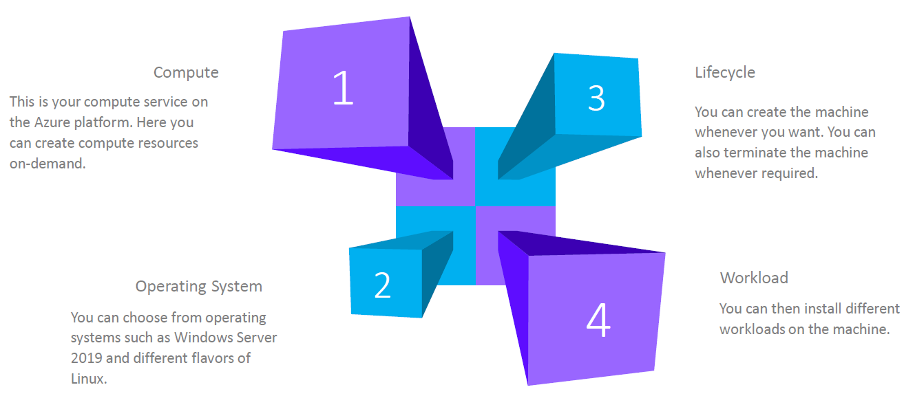

### AZURE VIRTUAL MACHINE – KEY CONCEPTS

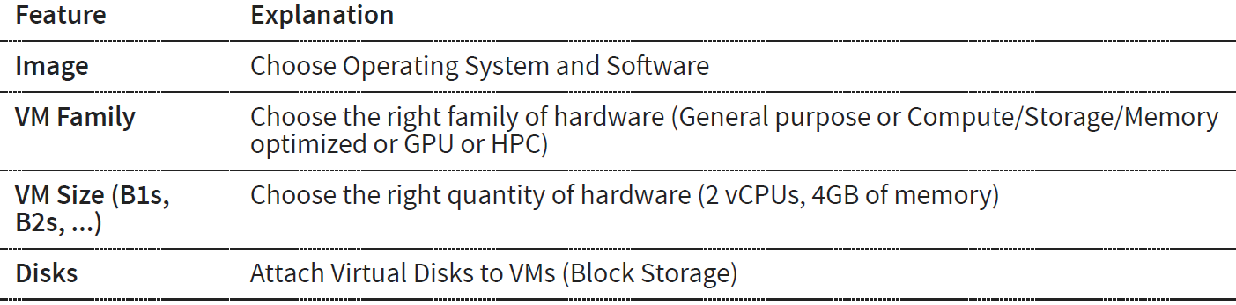

## DEPLOYING A VIRTUAL MACHINE

* When we deploy a virtual machine – there are other resources also get deployed with it.
* ***VM is a compute resource in Azure Platform. It is an Infrastructure as a service in azure platform***

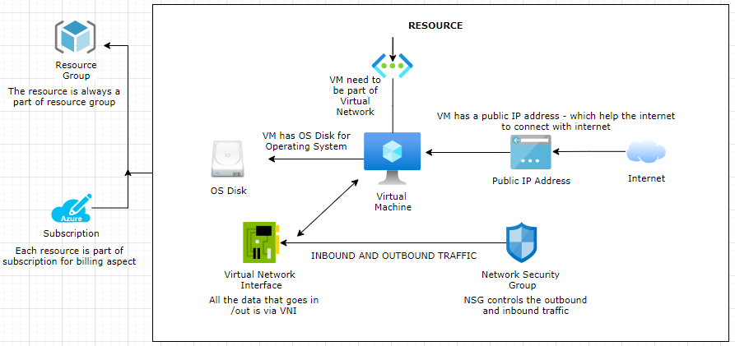

#### RESOURCE DEPLOYED WITH AZURE VM

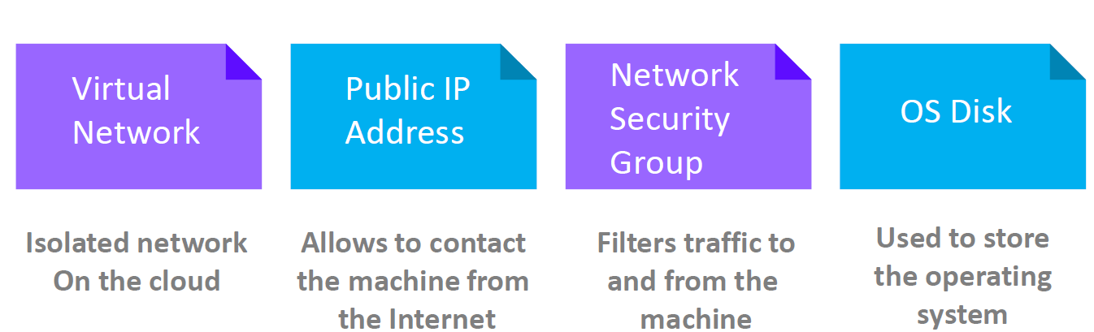

|  |  |
| --- | --- |
| OS DISK | * The virtual machine has OS Disk where operating system can be installed * Addition disk can be added too |
| VIRTUAL NETWORK INTERFACE | * Virtual Network Interface is like network interface card * All the data that goes in or out go via Virtual Network Interface |
| VIRTUAL NETWORK | * Every VM is part of a Virtual Network. |
| NETWORK SECURITY GROUP | * It controls all the inbound and outbound traffic to and from the VM |
| PUBLIC IP | * The VM are always associated to a public ip address –through which the internet can connect with the VM |

### DEPLOYING WINDOWS VM

#### BASIC

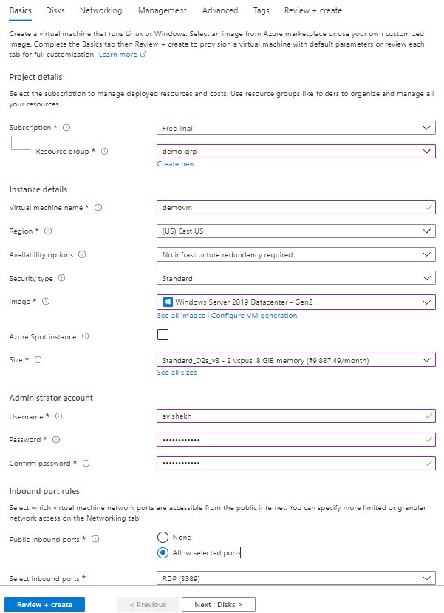

|  |  |
| --- | --- |
| RESOURCE GROUP | The resource group of the VM |
| VM NAME | Name of the Virtual machine |
| REGION | Region in which this VM will be created |
| IMAGE | This is the name of the image – which will be used to set-up OS in the VM. |
| SIZE | This defines the size of the resources in the VM like CPUs and RAM |
| SELECT INBOUND PORTS | This defines on which port the inbound traffic to VM is allowed. For window we user RDP(Remote Desktop) at port 3389 |

#### DISK

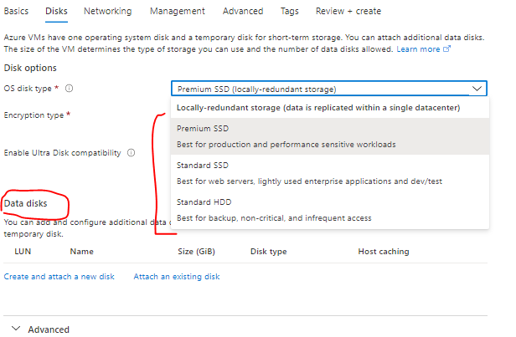

|  |  |
| --- | --- |
| OS DISKTYPE | * This is the disk which will be used for the storage of data |
| DATA DISK | * When we configure the VM – by default we get the OS disk . For additional disk we can add as a Data disk to the VM |

#### NETWORKING

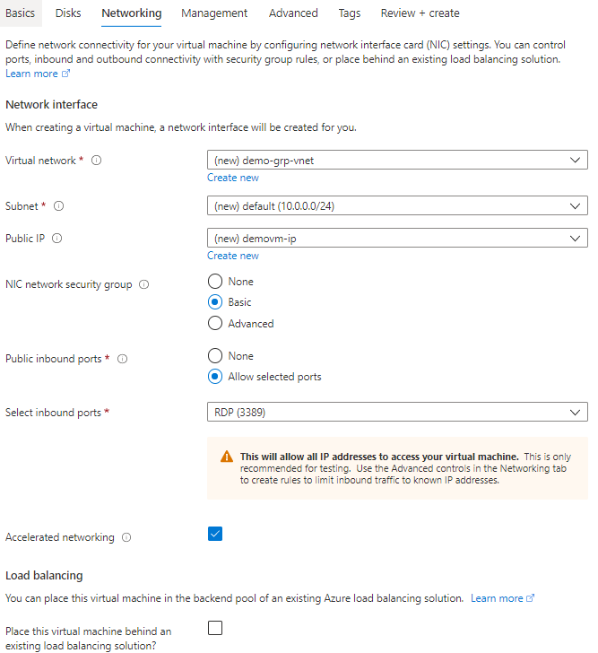

|  |  |
| --- | --- |
| VIRTUAL NETWORK |  |
| SUBNET |  |
| PUBLIC IP ADDRESS | The VM can be accessed on Internet using its public IP address |

#### VM CREATED

* The below diagram shows the created VM and other related resources which are created with the VM like NIC, VM , NSG and public IP address.

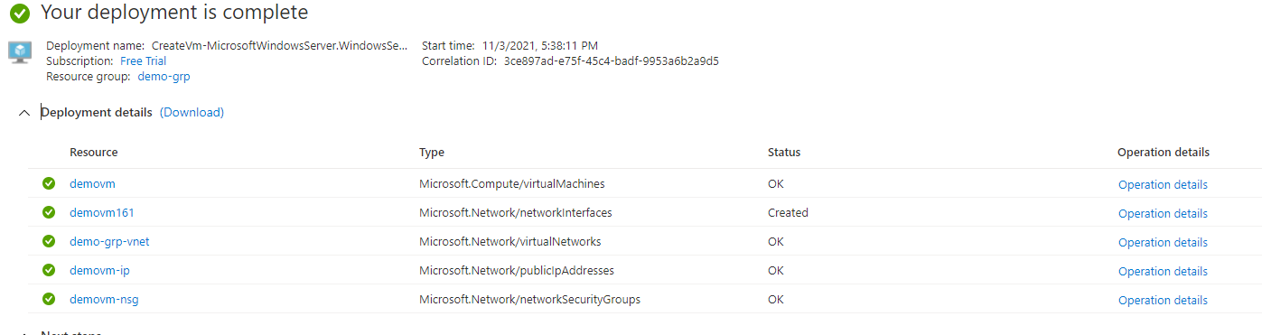

#### DELETING A VM

* From the *menu 🡪 All Resources*. Select all the resources which are related to the VM 🡪 Type yes and Delete

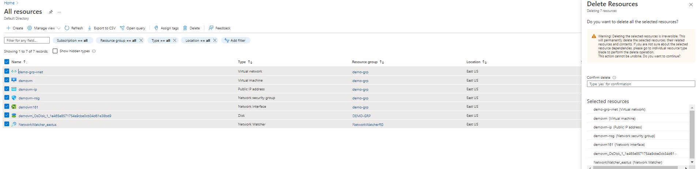

#### CONNECTING TO VM (WINDOWS) USING RDP

|  |  |
| --- | --- |
|  | * To connect with Windows based VM we use RDP * SSH is used to connect to Linux based VM |
|  | * To connect to the windows VM- download the RDP file * Open the downloaded RDP and Enter the username/password (used while creating the VM) |

### DEPLOYING LINUX VM

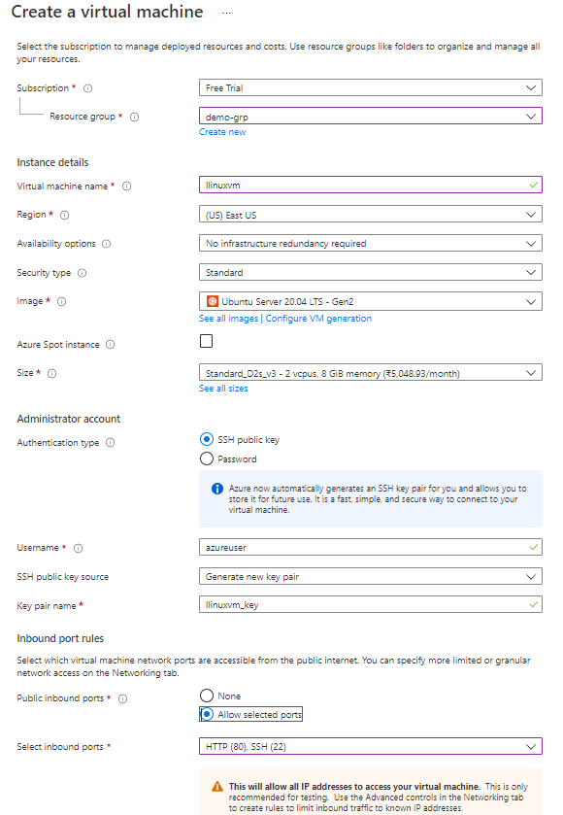

|  |  |
| --- | --- |
|  | * This will show a pop- up to download the SSH key * Download the SSH key – This key will be used to login to VM using SSH. * Note to connect with Linux VM we use SSH. |

**RESOURCES CREATED WITH VM**

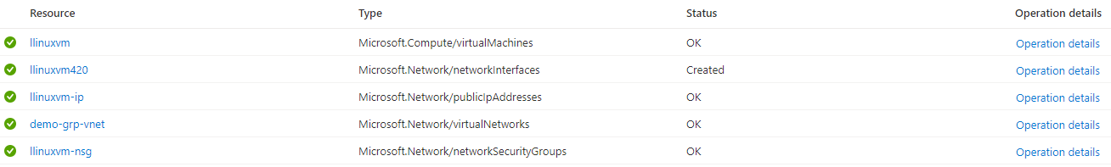

#### CONNECTING TO VM (SSH)

* Open the Cloud Shell and choose Bash
* Select the subscription 🡪 Create Storage

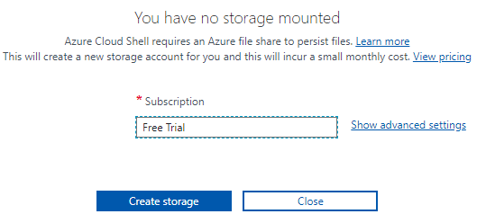

* Upload the SSH key using upload option 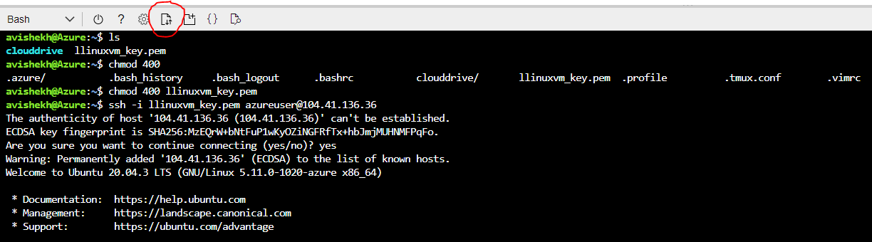
* Navigate to VM 🡪 Connect 🡪SSH . Follow the steps to SSH the VM

### INSTALLING SOFTWARES IN VM

#### INSTALLING NGINX (HTTP SERVER)

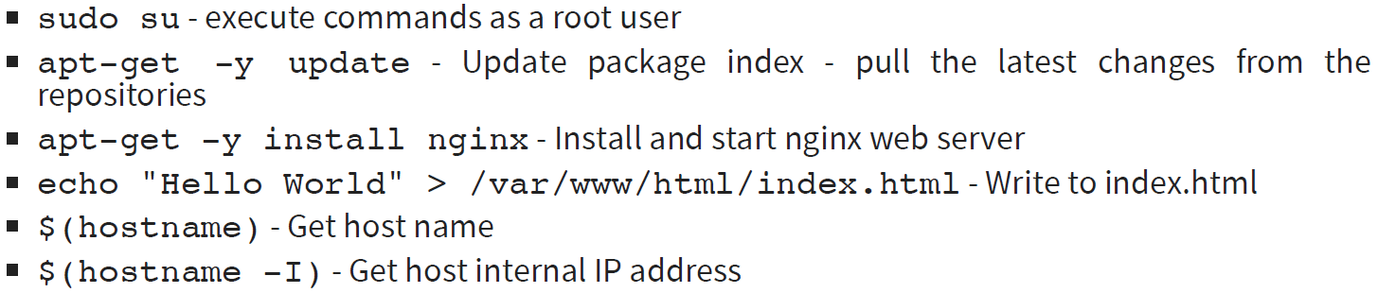

* The nginx webserver can be accessed using the public IP address of the VM(<http://104.41.136.36/> )

##### ADDING INBOUND PORT RULE

* We can add the inbound port rule to accept the incoming request. For example – we can enable the HTTP service at port 80 by adding a new inbound port rule.
* The same can be done while creating the VM (***Basic 🡪 Select inbound port***)

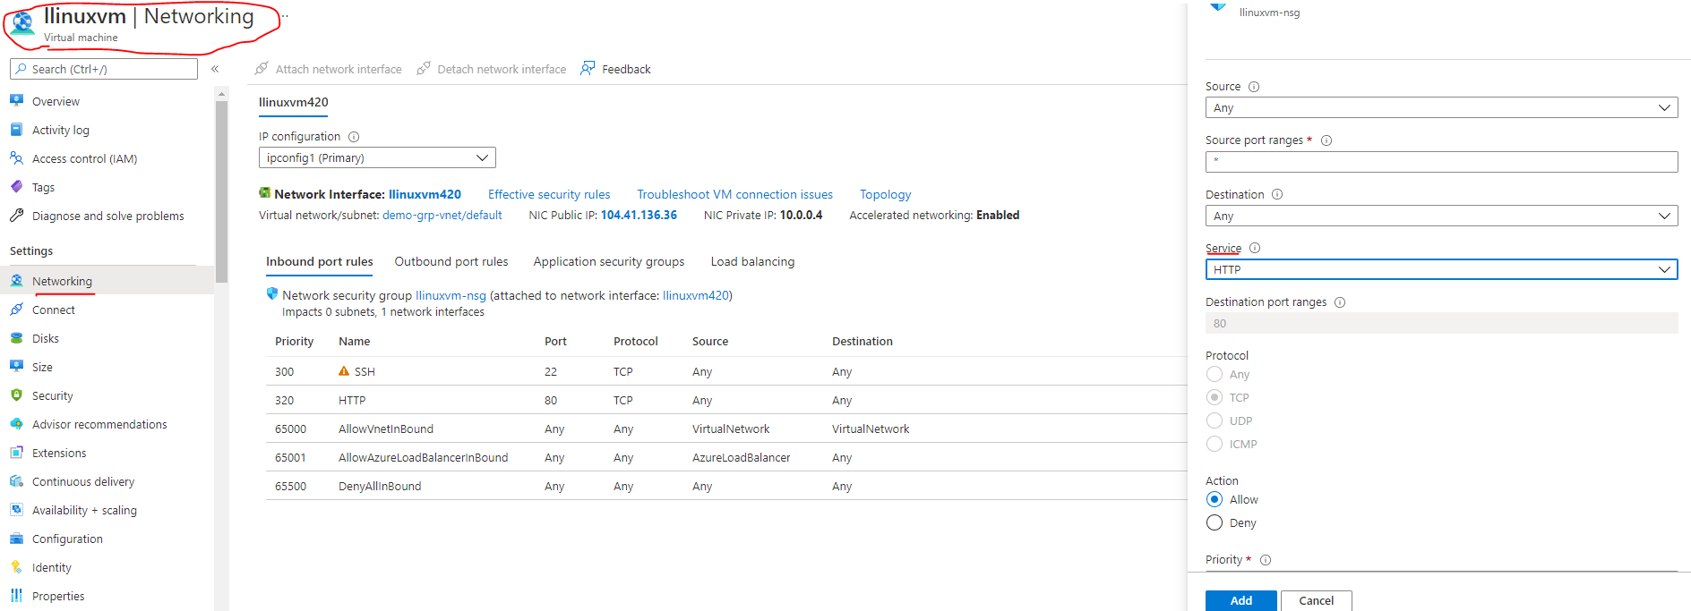

#### USING CLOUD INIT

* In the above steps – We first created the VM and the installed the nginx server. We did all by doing the “***ssh***” and running command from cloud shell.
* Just In case if we want to run a specific set of command after the VM start up – we can write the series of command in “Advanced Tab” 🡪 Cloud init as a bash script. As show below.

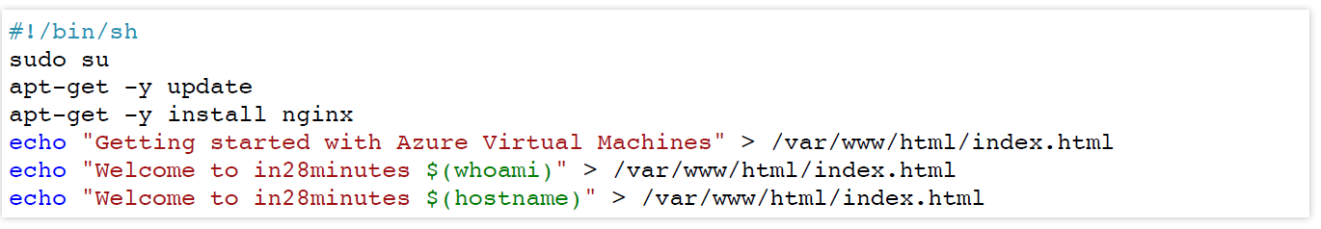

## QUOTA OF VM

* We do have a limit on number of VM we can create the number of VM we can create. The limitation is always tied to the type of subscription we have.
* Navigate to Dashboard 🡪 Subscription 🡪 Open the subscription 🡪 Usage and Quota

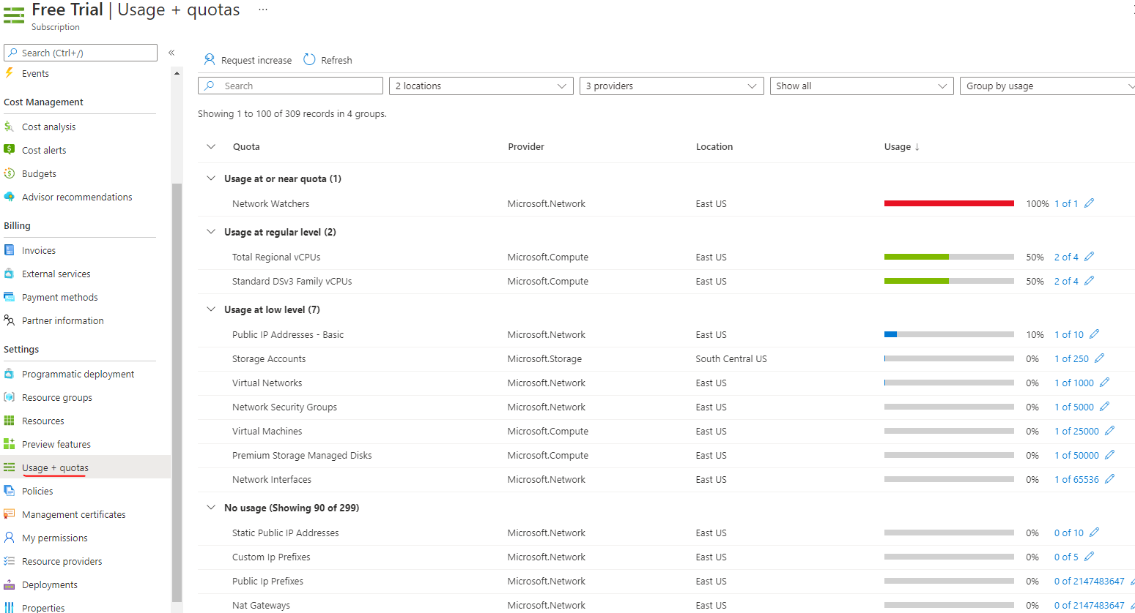

* Note – when we delete the resource group – this will delete all the resources in that resource group.

## AZURE MARKET PLACE

|  |  |
| --- | --- |
|  | * Azure marketplace offers multiple azure services as a template * For example – if we need a WordPress solution and want to install the solution to one of the VM- we can use the marketplace. * As WordPress is entirely different company which gives a service via Azure marketplace |

## AVAILABILITY

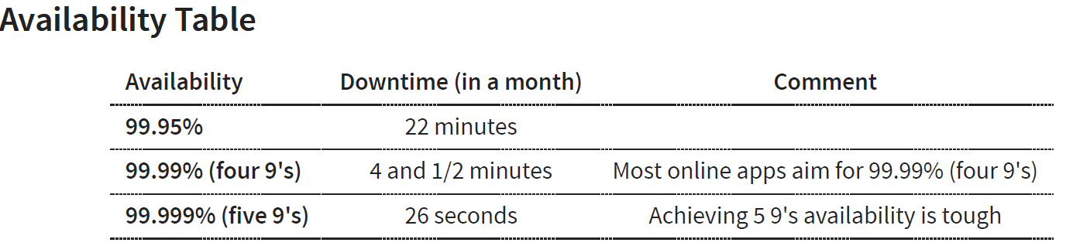

### INCREASING THE AVAILABILITY

* **SINGLE INSTANCE VM:** If we are using single instance VM we can use a specific disk type . Below is the availbility – when we select a spefic disk type(from Disk Tab)

|  |  |
| --- | --- |
| **DISK TYPE** | **AVAILABILITY** |
| Premium SSD or Ultra Disk | 99.9% |
| Standard SSD Managed Disks | 99.5% |
| Standard HDD Managed Disks | *95%* |

Two or more instances in same Availability Set: 99.95%

* Availability set is a logical grouping of VMs
  + **FAULT DOMAINS**: Group of VMs sharing a common power source and network switch. We can create upto 3 fault domains
  + **UPDATE DOMAINS**: Group of VMs that are rebooted (updated) at the same time.We can create up to 20 update domains
* Two or more instances in two or more Availability Zones in the same Azure region: 99.99%
* ***Summary: Create multiple instances in multiple AZs if you want high availability***

### AVAILABILITY SETS

AVAILIBILITY SET AND ZONES ARE CREATED TO INCREASE THE AVALIBILITY OF THE APPLICATION DEPLOYED TO VMS

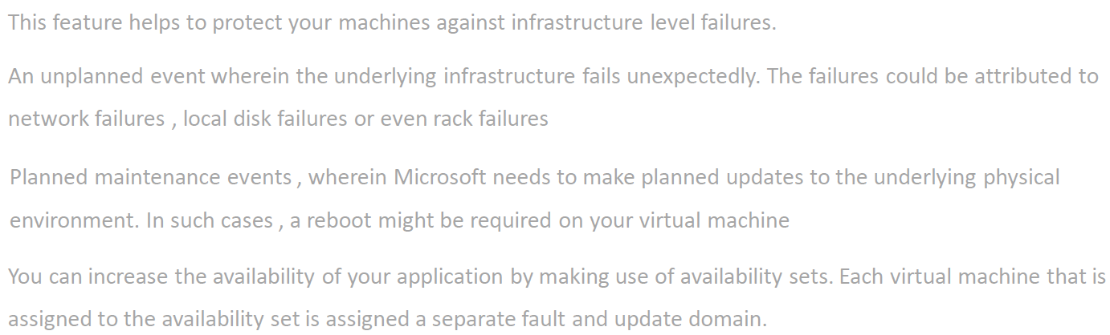

|  |  |
| --- | --- |
|  | * When we deploy the application is multiple VMs – these VM are actually created in phycial server in Azure Data Center. * The phycial server has its dedicated power source and networking. * When we spin-up a VM – we cannot control in which phycial server the VMs are created. * Just in case the physical server goes down (may be due the power source) , then both VMs will go down and hence the application. * To solve this option Azure platform has offers “Availability Set” |

* When a VM is created it is configured to be part of Fault Domain and Update Domain.
* This feature helps to protect your machines against infrastructure level failures.
* An unplanned event wherein the underlying infrastructure fails unexpectedly. The failures could be attributed to network failures , local disk failures or even rack failures
* Planned maintenance events , wherein Microsoft needs to make planned updates to the underlying physical environment. In such cases , a reboot might be required on your virtual machine
* You can increase the availability of your application by making use of availability sets. Each virtual machine that is assigned to the availability set is assigned a separate fault and update domain.

|  |  |  |  |  |  |  |  |  |  |  |
| --- | --- | --- | --- | --- | --- | --- | --- | --- | --- | --- |
| |  |  |  | | --- | --- | --- | | **UD1** | **VM1** | **VM3** | | **UD2** | **VM2** | **VM4** | |  | **FD1** | **FD2** | | * In the following matrix diagram – Virtual Machine VM1 & VM2 belong to a Fault Domain (FD1)and VM3 and VM4 belong to fault domain FD2 * VM1 and VM3 belong to update domain UD1 and VM2 an VM4 belong to update domain UD2 |

* As the fault domain shares the common power source and network switch – Just in case some goes wrong with this fault domain – then the application will be still available via VM3 and VM4 and vice versa.
* When the physical server needs an update – It will be updated based on update domain. Hence – if update domain UD1 is getting updated then applicatiomn will be available via VM2 and VM4.

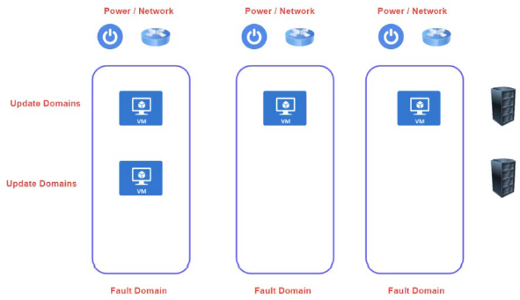

#### EXAMPLE

* Let’s create 2 VMs and make them a part of a availability set. Here Azure will make sure that VMs are properly distributed among fault and update domain.

*CREATING THE FIRST VM*

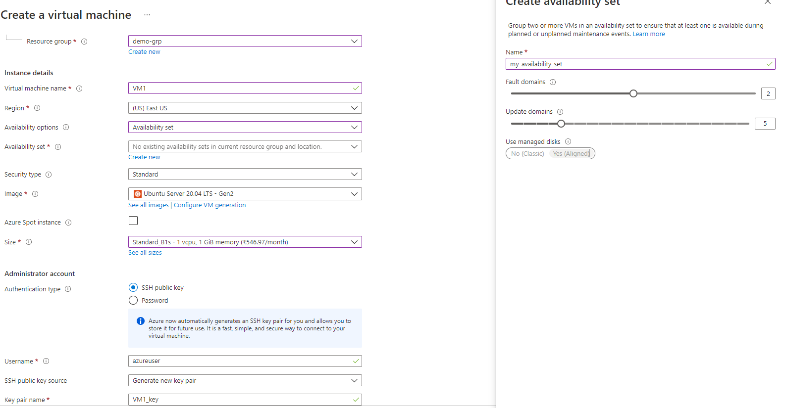

*AVAILABILITY SET STATUS:* The first VM is created in Fault Domain = 0 and update Domain= 0

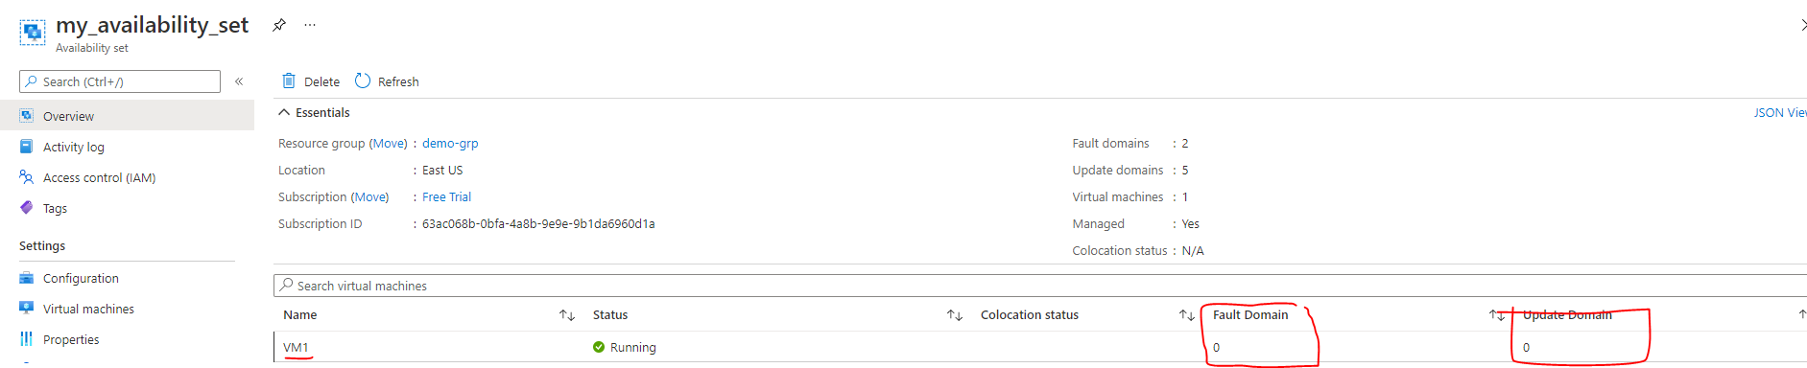

*CREATING THE SECOND VM IN THE SAME AVAILABILITY SET*

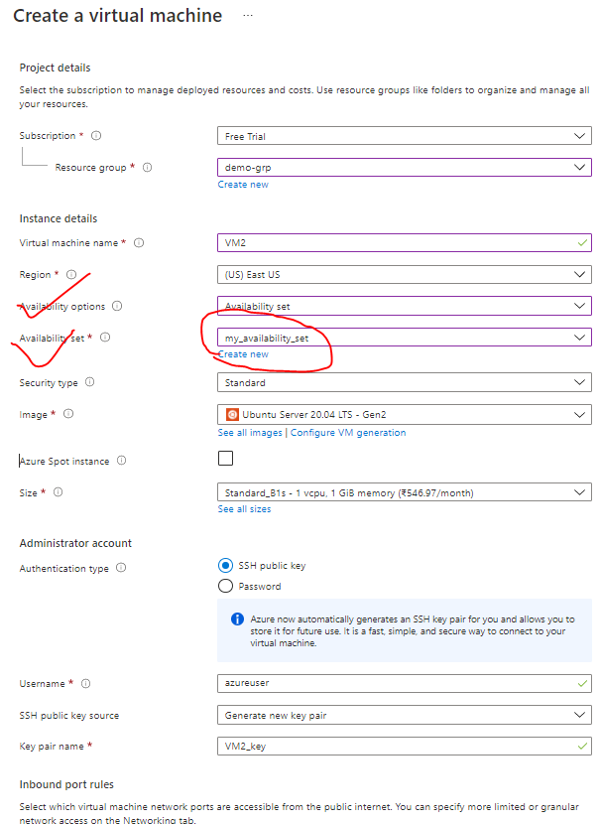

*AVAILABILITY SET STATUS:* The second VM is created in Fault Domain = 1 and update Domain= 1



* Hence Azure makes sure that VMs are evenly distributed between the Fault and update domain in a availability zone.
* The configuration of availability set for VM can only be done while creating the VM. VM belong to another availability set cannot eb migrated to. another availability set

**Note: The application deployed to a VM needs to be synced to another VM manually even it belong to same availability set.**

### AVAILABILITY ZONES

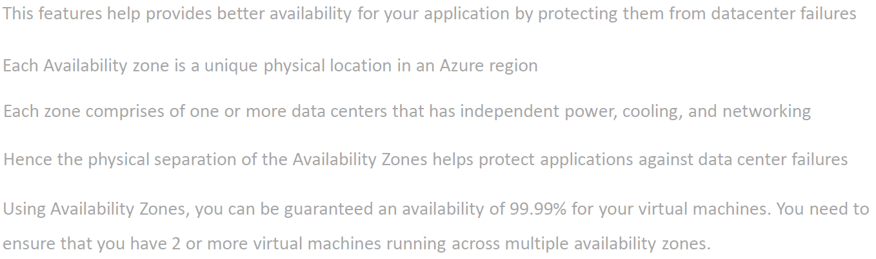

* In a specific region – we have multiple zones and each zone is a collection of data centers.
* Availability zones are unique physical location that are equiped with independent power , colling and networking.
* This features help provides better availability for your application by protecting them from datacenterfailures
* Each Availability zone is a unique physical location in an Azure region
* Each zone comprises of one or more data centers that has independent power, cooling, and networking
* Using Availability Zones, you can be guaranteed an availability of 99.99% for your virtual machines. You need to ensure that you have 2 or more virtual machines running across multiple availability zones.

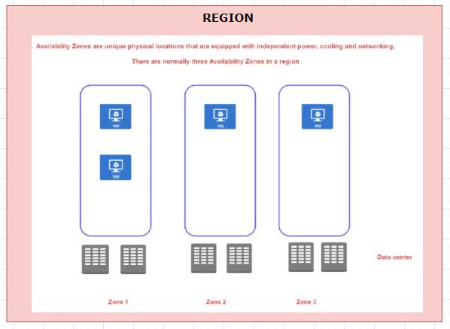

* When we create a VM in an availability zone – It is in turn mapped to the data center in that availability zone.
* The advantage we get with availability zone is that – if a data centers in a zone goes down – the application will be up and running from other zones in a specific region.

### NOTES ON AVAILABILITY ZONES AND SET

* There is no extra cost involved in creating availability zone or sets. But the is a costing aspect – when it comes to VM communication between the Zones. But this cost is not applicable when it comes to availability set as those VM are part of same physical data center.
* When we create a VM is availability zone or set – it our responsibility to sync the application in all the newly created VMs- To achieve the sync we can make use of extension of custom script called “Cloud Init Script”.

#### EXAMPLE

|  |  |  |  |  |  |  |  |  |  |  |
| --- | --- | --- | --- | --- | --- | --- | --- | --- | --- | --- |
|  | * For a region we have availability zone. * Lets create 2 VMs in two different availabilty zones in a same region.  |  |  |  | | --- | --- | --- | | VM | REGION | AVAILABILITY ZONE | | VM1 | EAST US | 1 | | VM2 | EAST US | 2 | |

CREATING THE VM IN AVAILIBILITY (ZONE -0 ; REGION – EAST US)

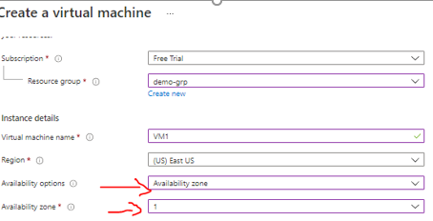

**VMS IN DIFFERENT AVAILIBILITY ZONE**

|  |  |
| --- | --- |
| VM1- OVERVIEW | VM2- OVERVIEW |
|  |  |

**WHY SHOULD I CREATE AVAILABILITY SETS IF WE HAVE AVAILABILITY ZONE?**

* When we create VM in different availability zone, there is an extra cost involved – which is called bandwidth pricing (<https://azure.microsoft.com/en-us/pricing/details/bandwidth/> ).
* Hence, we need to consider the bandwidth pricing while creating the VM is different availability zones.
* Bandwidth Price involve the charges on the data transfer between VM on different zones, especially when it comes to data used while syncing the application between VMs

## VIRTUAL MACHINE SCALE SETS

* Virtual machine scale set simplify the creation and management of multiple VMs(group of VMs)
* VM scale set also allow as to add a load balancer
* Supports manual and auto scaling
* Distribute VM instances across multiple Availability Zones
* Supports 1000 VM instances in a single scale set.

## AZURE DEDICATED HOST

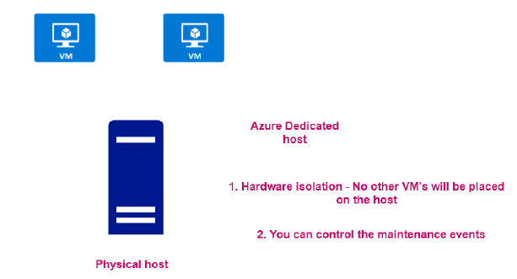

* When we create VMs, they are get created in physical server/ host in the azure data center
* In Azure – it come with a capability to assign the entire physical host as a resource. Note this capability are usually leveraged by large scale organization.

#### ADVANTANGE OF DEDICATED HOST

* As it is a dedicated host – no other VM can be placed in the host.
* We can be able to control the maintenance events of the VMs

#### CREATING DEDICATED HOST

* Navigate to Market Place 🡪 Search “Dedicated Host”.
* The creation of Dedicated host failed in below diagram as it need more resources (i.e 96 CPU) – which are not applicable for free subscription.

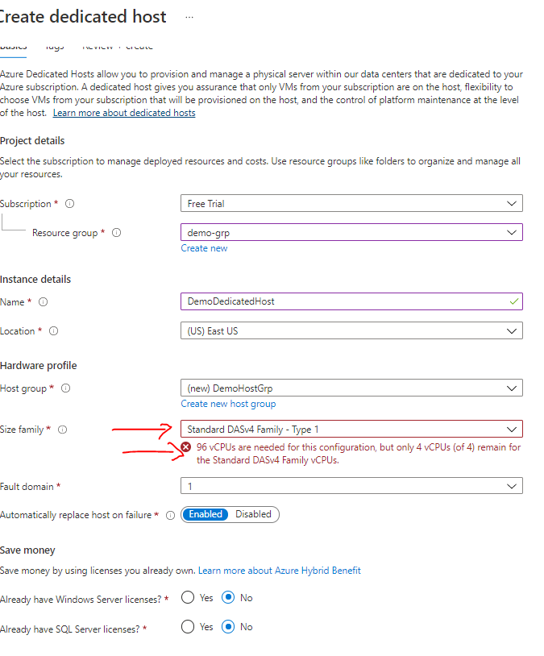

## AZURE SPOT INSTANCES

## WORKLOAD

|  |  |
| --- | --- |
|  | * ***Workload is unit functionality which can be an application or service.*** * For example – If we have a web application which we want to host or a database server they are called as “workload”. |

## IMPORTANT USE CASES AND SOLUTIONS

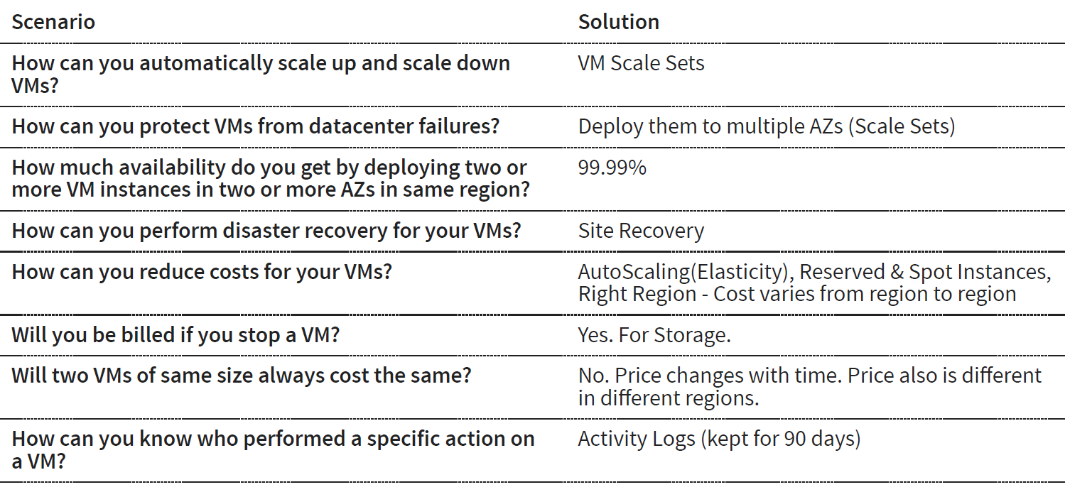

# AZURE VIRTUAL NETWORK

* The Virtual network is a is always a range of IP address.
* When we create a VM it is always get a private IP address. If the private IP of the VM fall in the range of virtual machine, then the machine will be part that virtual network. Hence, The private IP helps in locating the VM in the vitual network.
* The Azure Virtual Network service is used to define an isolated network in Azure. The virtual network can then be used to host the resources such as Azure virtual machines.
* The Azure virtual network gets assigned an address space (IP address range) which we can specify when we create an Azure virtual network.

## CREATING A VIRTUAL NETWORK

* Usually the Virtual network is created aling with the VM. But we can also able to create Virtual machine upfront and the tie the VM into it.

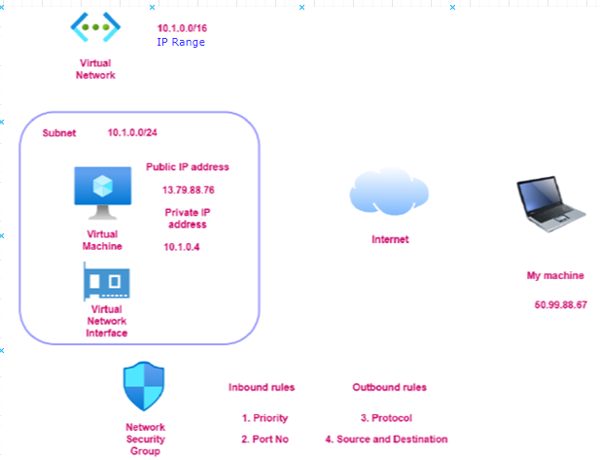

* ***Step 1***: Lets create a Virtual al network. This wizard will create subnet as well in the SUBNET as well network.

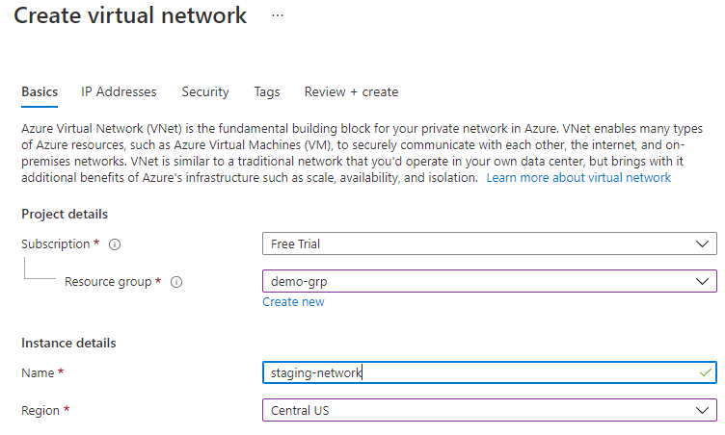

* *Note: When we create a VM needs to be part of virtual network*
* Virtual network has something called IP address range / address space as shown below

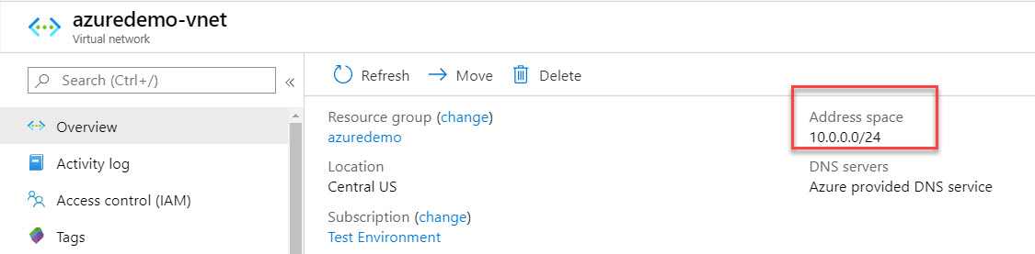

## CREATING A SUBNET IN VIRTUAL NETWORK

After creating a Virtual Network – We can then add subnets to the Azure virtual network. This helps divide the network into more logical segments.

An example is shown below of having multiple subnets. You could have one subnet named SubnetA in the virtual network to host your Web servers and another subnet to host the Database servers.

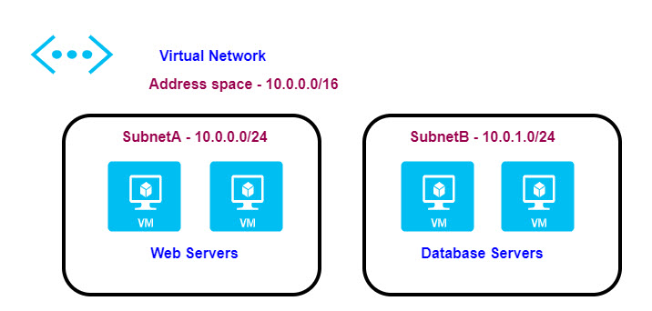

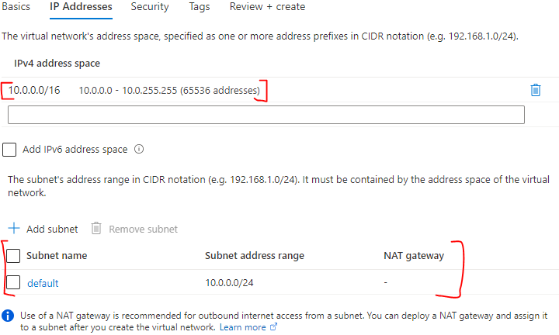

## CREATING A VIRTUAL MACHINE IN VIRTUAL NETWORK

* While creating a VM we need in a virtual network – we need to select the same region as of the Virtual Network.
* If the correct region is selected in the “Basic” tab – then only the Virtual network will be visible in “Networking” tab.

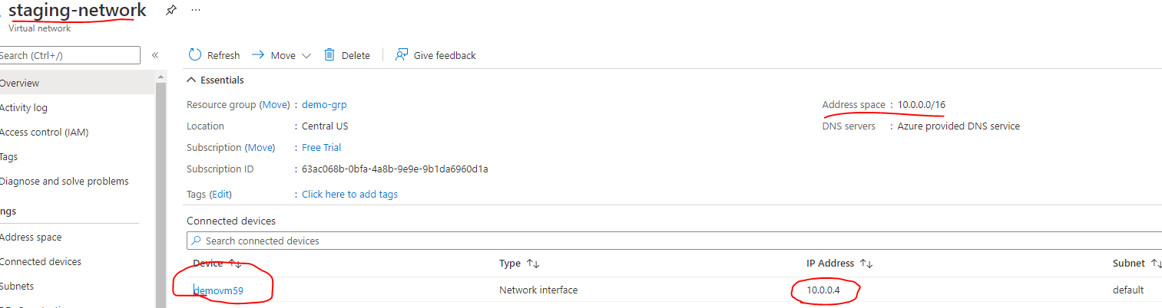

* The above diagram shows the VM created in the virtual network.
* The IP of the VM lies within the range of Virtual Network

*Questions*

1. *If I have pre-created VM (which belong to some another virtual network) can I change the Virtual network of the VM ? - No*
2. *Can a VM can be a part of two different Virtual Network? – No*

## COMMUNICATION ACROSS VIRTUAL MACHINES IN A VIRTUAL NETWORK

* The virtual machines within the Virtual network can communicate using their private IP address.

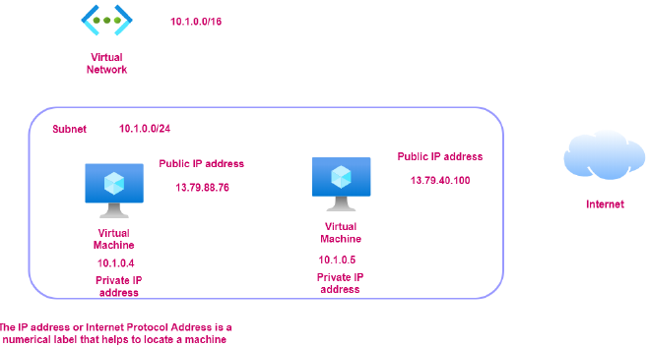

## NETWORK SECURITY GROUP

* Network security group is used to filter the in-bound and outbound traffic which is flowing to the VM.
* All the data flows into VM go through the Virtual Network Interface. Hence – when we access the VM using the public IP address. The traffic flow via Virtual Network interface.
* The Network security group (which is attached to the Virtual Network Interface) - has set of rules which controls / filters the inbound and outbound traffic. It’s like a basic firewall.
* The NSG rules can also be applied on subnet layer as well.
* All the inbound and outbound rules can be set from “Networking” in VM dashboard.



* By default, all traffic into a virtual machine is DENIED. We must explicitly add rules to allow traffic into a virtual machine
* There are also outbound rules to control the traffic flowing out of the virtual machine. By default, all traffic outbound onto the Internet is *allowed*.
* The inbound / outbound rules include the rules around protocol, port number, Source and Destination and Priority.
* The Network security rule are evaluated from top to bottom. If the rule matches in rule, rest of the rules will be ignored

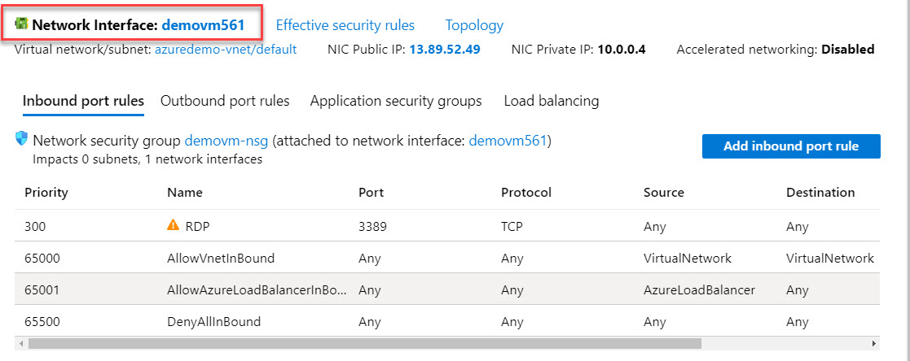

## APPLICATION SECURITY GROUP

|  |  |
| --- | --- |
|  | * Let’s say – we have VM which has webserver which is in turn communicating with a VM having DB server. * Application Security Group is one of the ways of filtering traffic using IP address. * In the above example if we have multiple VM(webserver) communicating with the DB server. We create an Application Security Group – which has list of all such VMs. * At the DB VM side – we have to make sure that its NSG should accept the incoming request from the Application Security Group- which in turn means DB VM is allowing the incoming request from webservers |

## NETWORK CONNECTIVITY OPTIONS

### **VIRTUAL NETWORK PEERING**

* Virtual Network Peering is used to connect two Azure virtual networks together via the backbone network.
* Azure supports connecting two virtual networks located in the same region or networks located across regions.
* Once we enable virtual network peering between two virtual networks, the virtual machines can then communicate via their private IP addresses across the peering connection.
* We can also peer virtual networks that are located across different subscriptions.
* The virtual networks can't have overlapping CIDR blocks.

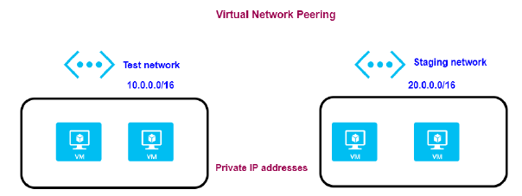

### **SITE-TO-SITE VPN CONNECTION**

* A Site-to-Site VPN connection is used to establish a secure connection between an on-premise network and an Azure network via the Internet.

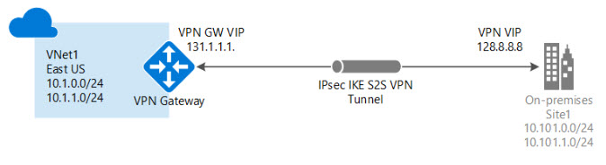

* On the on-premise side, you need to have a VPN device that can route traffic via the Internet onto the VPN gateway in Azure. The VPN device can be a hardware device like a Cisco router or a software device ( e.g Windows Server 2016 running Routing and Remote services). The VPN device needs to have a publically routable IP address.
* The subnets in your on-premise network must not overlap with the subnets in your Azure virtual network
* The Site-to-Site VPN connection uses an IPSec tunnel to encrypt the traffic.
* The VPN gateway resource you create in Azure is used to route encrypted traffic between your on-premise data center and your Azure virtual network.

### **POINT-TO-SITE VPN CONNECTION**

* A Point-to-Site VPN connection is used to establish a secure connection between multiple client machines and an Azure virtual network via the Internet.

#### USE CASE

* If we have multiple Client workstation which needs a connection to the Virtual Network.
* Usually, the VM can be accessed using the public IP address.
* Since the connections is via internet hence for security standpoint – the client workstations should talk to VM via private IP address. For the communication via Private IP address with the VM , the client workstation has to connect via VPN.
* For enable this set-up we need to deploy a resource called VPN gateway resource and configure Point to site VPN connection.
* In addition to that the set up make use of certificates for authentication to make the connection more secure

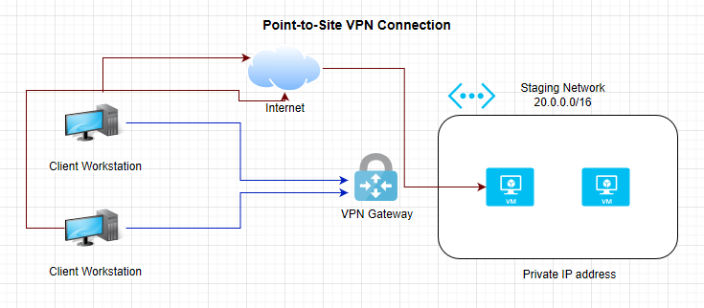

## AZURE EXPRESS ROUTE

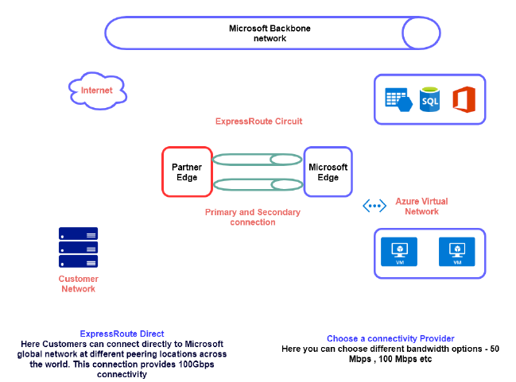

# AZURE CORE SERVICES

## AZURE STORAGE

* A storage account provides a unique namespace for your Azure Storage data, that's accessible from anywhere in the world over HTTP or HTTPS. Data in this account is secure, highly available, durable, and massively scalable.
* Azure storage account provides the storage on cloud and we use a Azure storage service account for the same.
* Azure Storage account is a service – but based on type of storage account we can make use of different storage/services
* Azure Storage is also used by infrastructure as a service virtual machine, and platform as a service cloud services.

### CREATING A STORAGE ACCOUNT (GENERAL PURPOSE V2 STORAGE ACCOUNT)

* Create Resource 🡪 Storage Account
* Give the storage Account name

|  |  |  |  |  |  |
| --- | --- | --- | --- | --- | --- |
|  | Note : The general purposev2 storage acount we get call the services mentioned above  But for Premium Account type (Storage Account type ) – We can get a premium service for specific type like Block Service , File Service or Page blob Service   |  |  | | --- | --- | | BLOCK SERVICE | Its is used to store objects | | PAGE BLOB SERVICE | It is used to store hard disk drive of VM’s | |

### STORAGE ACCOUNT

* The general-purpose storage account is equipped with Container
* Containers are used for Storing BLOBs like images , video etc.)

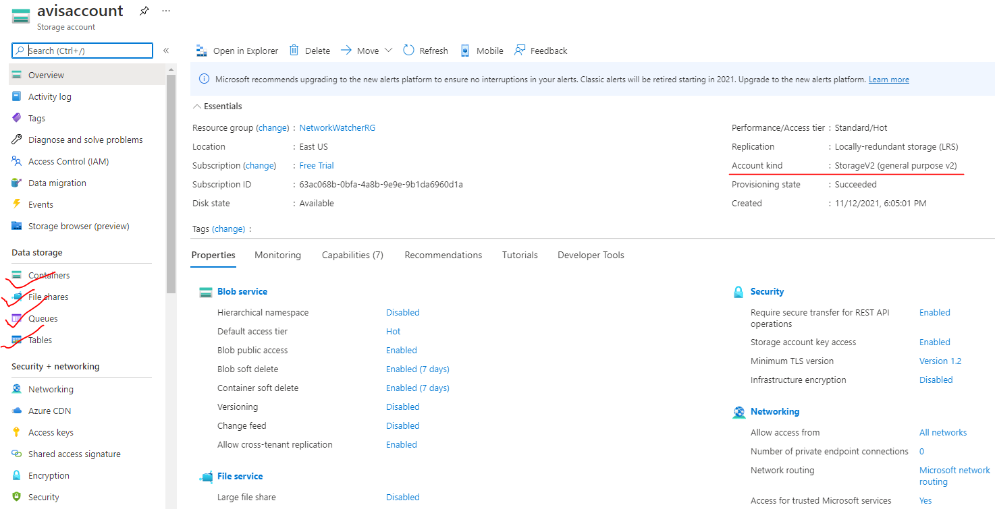

### TYPES OF STORAGE ACCOUNT

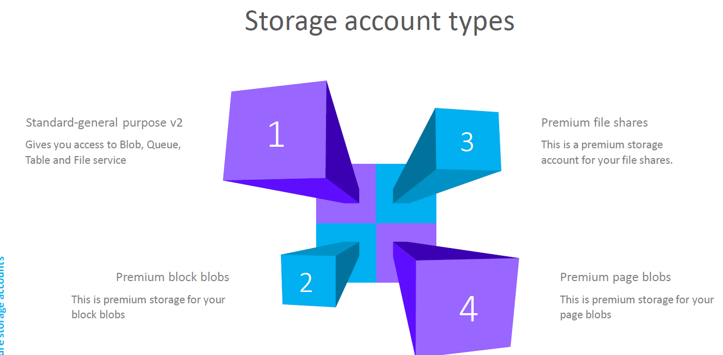

### DATA REDUNDANCY IN AZURE STORAGE ACCOUNT

#### WHAT IS REDUNDANCY?

|  |  |
| --- | --- |
|  | * When we store a data in a storage account – it is basically get stored in a physical storage device. * When azure store in the data in the storage devices – it stores multiple copies of the data * This helps in protecting the planned and unplanned events, transient hardware failures , network and power outage. |

The different statergies Azure uses to make multiple copies of the data are following

1. **LOCALLY-REDUNDANT STORAGE**
2. **GEO-REDUNDANT STORAGE**
3. **ZONE-REDUNDANT STORAGE**
4. **GEO-ZONE-REDUNDANT STORAGE**

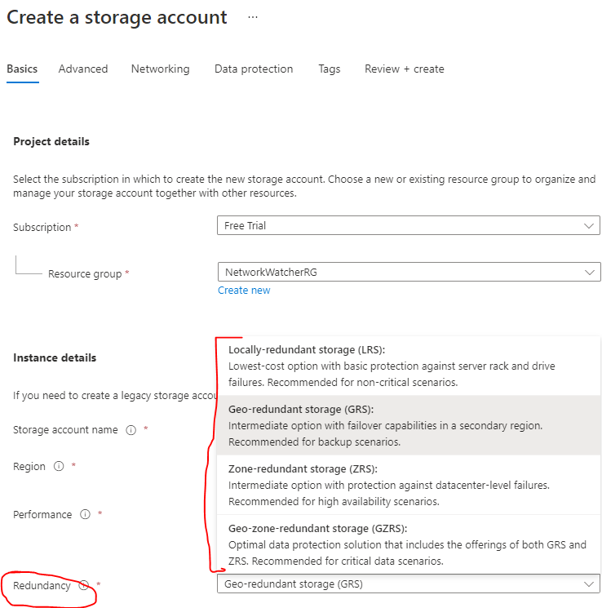

#### LOCALLY-REDUNDANT STORAGE

|  |  |
| --- | --- |
|  | In this strategy of making the copies of data   * In an Azure data center 3 copies of data are made in different storage devices within a data center * Hence event if there is failure (like rack or device failure) in one of the storage devices – the data will be still available |

#### ZONE-REDUNDANT STORAGE

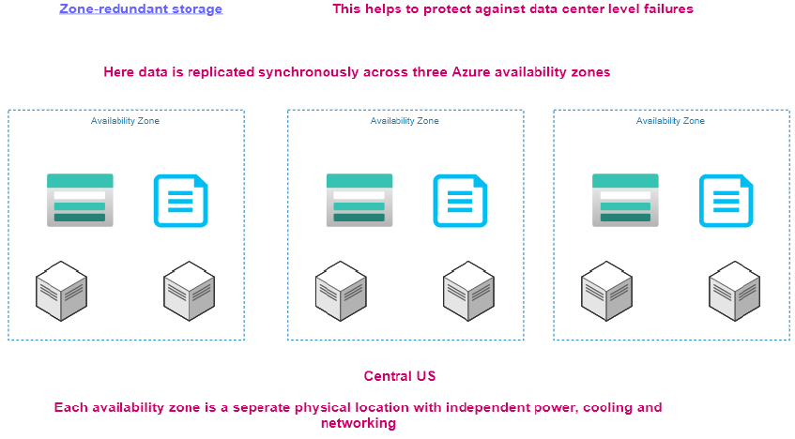

In Zone Redundant Storage

* This help in protecting against failure in a data center.
* Here the data is copied to 3 availability zones – Hence the data will be available even if a data center fails.

Note:

* Each availability zone resides in separate physical location.
* In this strategy- if the entire zone is not available (like Central US) , then all the availability zone will not be available. In this case we can go with Geo Redundant Storage.

#### GEO-ZONE-REDUNDANT STORAGE

* The data is first replicated to availability zones in a particular zone.
* After that the data is replicated to secondary region

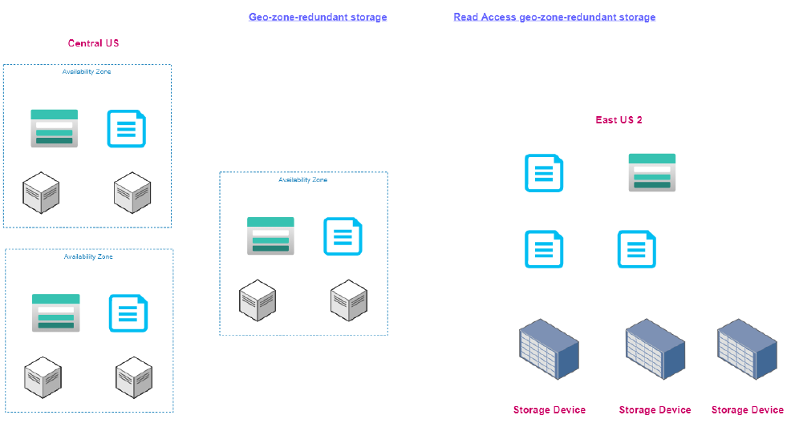

### CORE STORAGE SERVICES

|  |  |
| --- | --- |
| BLOB STORAGE | * Azure Blob Storage is an object storage solution that you can use to store massive amounts of unstructured data, such as text or binary data. * Blob Storage is ideal for serving images or documents directly to a browser, storing data for archivesor distributed access, streaming video and audio, and disaster recovery scenarios. |
| TABLE STORAGE | Azure Table Storage offers a NoSQL data store for key value pairs using large scale datasets.  You can use Azure Table Storage to store petabytes of semi-structured data,and keep your costs down. |
| QUEUE STORAGE | Azure Queue Storage provides asynchronous message queuing for communication between  application components,whether they're running in the cloud, on the desktop,on premises, or on mobile devices |
| FILE STORAGE | Azure File Storage offers fully managed file shares in the cloud, and shares are accessible  using industry standard network protocols.Mounting Azure file shares is just like connecting to shares on your local network. |
| DISK STORAGE | * Azure Disk Storage provides disks for virtual machines and applications to access and use as they need - similar to how they would access disks that were on premises. * Azure offers both solid state drives for higher performance workloads and conventional hard drives for your less critical business scenarios. |

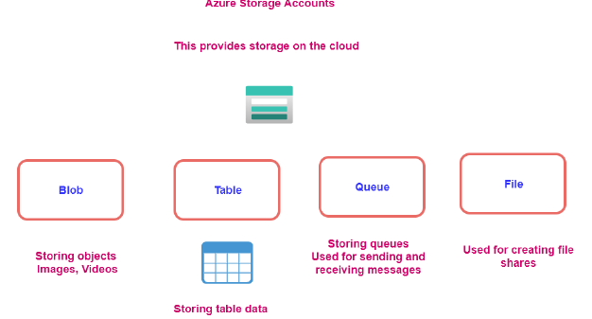

#### DISK STORAGE

|  |  |
| --- | --- |
| The following illustration shows an Azure virtual machine that uses separate disks to store different data.Diagram of two disks inside a virtual machine. One stores the operating system and one stores data. | * Disk Storage provides disks for Azure virtual machines. Applications and other services can access and use these disks as needed, similar to how they would in on-premises scenarios. Disk Storage allows data to be persistently stored and accessed from an attached virtual hard disk. * Disks come in many different sizes and performance levels, from solid-state drives (SSDs) to traditional spinning hard disk drives (HDDs), with varying performance tiers. You can use standard SSD and HDD disks for less critical workloads, premium SSD disks for mission-critical production applications, and ultra disks for data-intensive workloads such as SAP HANA, top tier databases, and transaction-heavy workloads. |

#### BLOB STORAGE

|  |  |
| --- | --- |
| * Azure Blob Storage is an object storage solution for the cloud. It can store massive amounts of data, such as text or binary data. * Azure Blob Storage is unstructured, meaning that there are no restrictions on the kinds of data it can hold. * Blob Storage can manage thousands of simultaneous uploads, massive amounts of video data, constantly growing log files, and can be reached from anywhere with an internet connection. | Blb Storage is ideal for:   * Serving images or documents directly to a browser. * Storing files for distributed access. * Streaming video and audio. * Storing data for backup and restore, disaster recovery, and archiving. * Storing data for analysis by an on-premises or Azure-hosted service. * Storing up to 8 TB of data for virtual machines. |

##### CONTAINER

The containers helps as to organize the blobs.

###### CREATING A CONTAINER

|  |  |
| --- | --- |
|  |  |
| * Enter the name of the container. * The container will hold all the blobs like image and videos * Using the upload option, we can able to upload the images and videos * Note : ***Anything uploaded in a container will have unique url.*** | |

##### ACCESSING THE BLOB

* All the BLOB items have a unique url. Click on the items to view its property
* The URl field will give the get the unique url of the BLOB Item(e.g. : <https://avisaccount.blob.core.windows.net/data/IMG-20210712-WA0012.jpg> )
* ***The items will be accessible when the Access level is not private.***

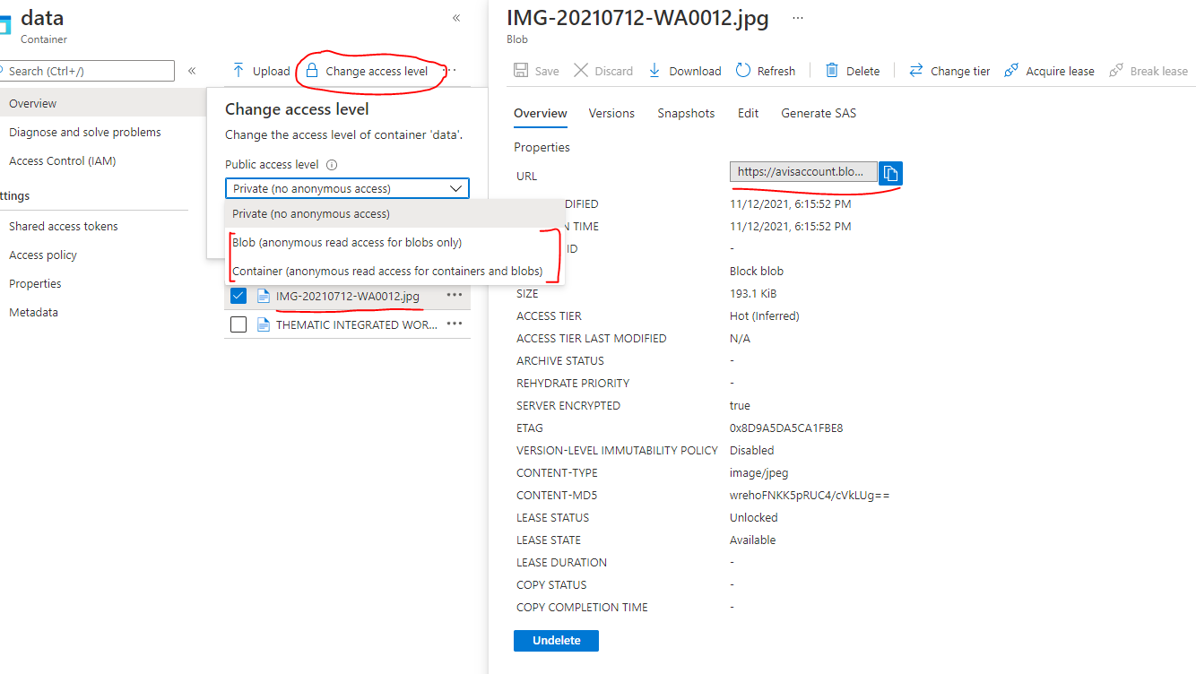

##### ACCESSING TIERS OF BLOBS



* Data stored in the cloud can grow at an exponential pace. To manage costs for expanding storage needs, it's helpful to organize your data based on attributes like ***frequency of access and planned retention period***.
* Data stored in the cloud can be different based on how it's generated, processed, and accessed over its lifetime. Some data is actively accessed and modified throughout its lifetime. Some data is accessed frequently early in its lifetime, with access dropping drastically as the data ages. Some data remains idle in the cloud and is rarely, if ever, accessed after it's stored. To accommodate these different access needs, Azure provides several access tiers, which you can use to balance your storage costs with your access needs.

***Azure Storage access tiers include***

Azure Storage offers different access tiers for your blob storage, helping you store object data in the most cost-effective manner. The available access tiers include:

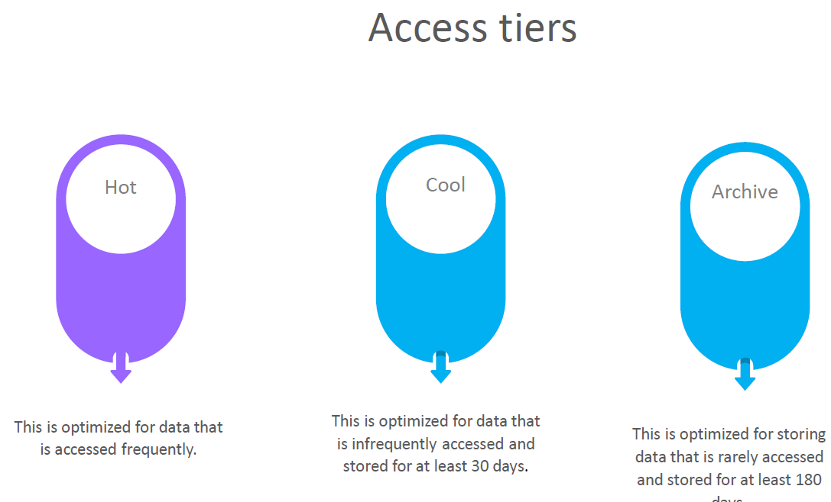

* **HOT ACCESS TIER**: Optimized for storing data that is accessed frequently (for example, images for your website).
* **COOL ACCESS TIER:** Optimized for data that is infrequently accessed and stored for at least 30 days (for example, invoices for your customers).
* **ARCHIVE ACCESS TIER**: Appropriate for data that is rarely accessed and stored for at least 180 days, with flexible latency requirements (for example, long-term backups).

The following considerations apply to the different access tiers:

* Only the hot and cool access tiers can be set at the account level. The archive access tier isn't available at the account level.
* Hot, cool, and archive tiers can be set at the blob level, during upload or after upload.
* Data in the cool access tier can tolerate slightly lower availability, but still requires high durability, retrieval latency, and throughput characteristics similar to hot data. For cool data, a slightly lower availability service-level agreement (SLA) and higher access costs compared to hot data are acceptable trade-offs for lower storage costs.
* Archive storage stores data offline and offers the lowest storage costs, but also the highest costs to rehydrate and access data.

The Access Tiers can be changed as shown below. Select the BLOB item 🡪 Change Tier 🡪 Select the Access Tier.

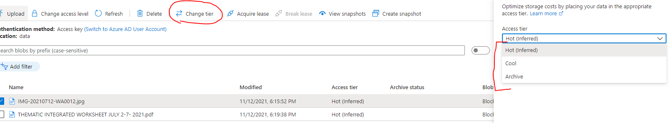

#### FILE STORAGE

Azure Files offers fully managed file shares in the cloud that are accessible via the industry standard Server Message Block and Network File System (preview) protocols. Azure file shares can be mounted concurrently by cloud or on-premises deployments of Windows, Linux, and macOS. Applications running in Azure virtual machines or cloud services can mount a file storage share to access file data, just as a desktop application would mount a typical SMB share. Any number of Azure virtual machines or roles can mount and access the file storage share simultaneously. Typical usage scenarios would be to share files anywhere in the world, diagnostic data, or application data sharing.

Use Azure Files for the following situations:

Many on-premises applications use file shares. Azure Files makes it easier to migrate those applications that share data to Azure. If you mount the Azure file share to the same drive letter that the on-premises application uses, the part of your application that accesses the file share should work with minimal changes, if any.

Store configuration files on a file share and access them from multiple VMs. Tools and utilities used by multiple developers in a group can be stored on a file share, ensuring that everybody can find them, and that they use the same version.

Write data to a file share, and process or analyze the data later. For example, you might want to do this with diagnostic logs, metrics, and crash dumps.

The following illustration shows Azure Files being used to share data between two geographical locations. Azure Files ensures the data is encrypted at rest, and the SMB protocol ensures the data is encrypted in transit.

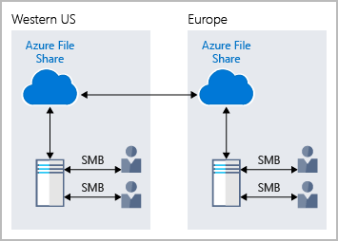

One thing that distinguishes Azure Files from files on a corporate file share is that you can access the files from anywhere in the world, by using a URL that points to the file. You can also use Shared Access Signature (SAS) tokens to allow access to a private asset for a specific amount of time.

Here's an example of a service SAS URI, showing the resource URI and the SAS token:

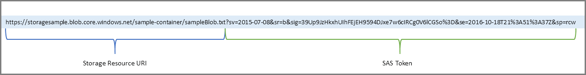

#### TABLE

* Azure Table storage is a service that stores **non-relational structured data (also known as structured NoSQL data)** in the cloud, providing a key/attribute store with a schemeless design.
* Because Table storage is schemeless,
  + it's easy to adapt your data as the needs of your application evolve.
  + Access to Table storage data is fast and cost-effective for many types of applications and is typically lower in cost than traditional SQL for similar volumes of data.
* We can use Table storage to store flexible datasets like user data for web applications, address books, device information, or other types of metadata your service requires.
* **We can store any number of entities in a table, and a storage account may contain any number of tables, up to the capacity limit of the storage account**.

##### WHAT IS TABLE STORAGE

* Azure Table storage stores large amounts of structured data. The service is a NoSQL datastore which accepts authenticated calls from inside and outside the Azure cloud. Azure tables are ideal for storing structured, non-relational data.

*Common uses of Table storage include*

* Storing TBs of structured data capable of serving web scale applications
* Storing datasets that don't require complex joins, foreign keys, or stored procedures and can be denormalized for fast access
* Quickly querying data using a clustered index
* Accessing data using the OData protocol and LINQ queries with WCF Data Service .NET Libraries
* We can use Table storage to store and query huge sets of structured, non-relational data, and the tables will scale as demand increases.

##### TABLE STORAGE COMPONENTS

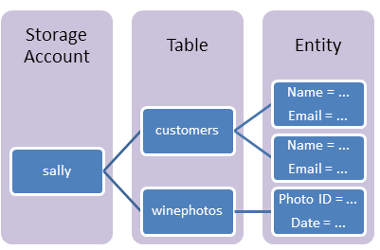

|  |  |
| --- | --- |
| **URL FORMAT** | * Azure Table Storage accounts format: http://<storage account>.table.core.windows.net/<table> * Azure Cosmos DB Table API accounts format: http://<storage account>.table.cosmosdb.azure.com/<table> |
| **TABLE** | A table is a collection of entities. Tables don't enforce a schema on entities, which means a single table can contain entities that have different sets of properties. |
| **ENTITY** | An entity is a set of properties, like a database row. **An entity in Azure Storage can be up to 1MB in size. An entity in Azure Cosmos DB can be up to 2MB in size** |
| **PROPERTIES** | * A property is a name-value pair. * Each entity can include up to 252 properties to store data. * Each entity also has three system properties that specify a partition key, a row key, and a timestamp. **Entities with the same partition key can be queried more quickly and inserted/updated in atomic operations.** * An entity's row key is its unique identifier within a partition. |

##### ADDING DATA TO TABLE

|  |  |
| --- | --- |
|  | * For table storage – we can create tables in the azure storage account. * To add data to the table 🡪 Navigate to Storage Browser 🡪 Navigate to the table 🡪 Add Entity * An Entity has 2 parts   + Partition key   + RowKey |

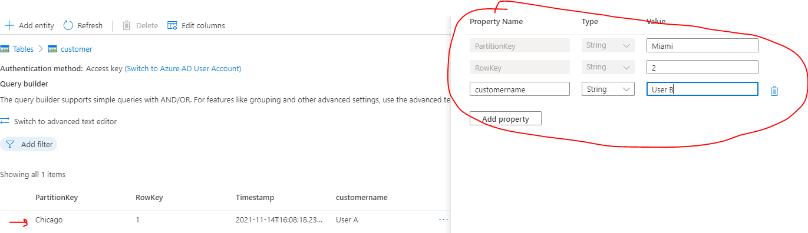

###### PARTITION KEY AND ROWKEY

* PARTITION KEY: If we have huge amount of data in a table, dividing the table into partition – it becomes easier to search for an entity in particular partition.
* ROWKEY: Rowkey helps in searching the data within the partition.

Example: Let’s say we are creating a “customer” table. The table can be divided in partition, it can be customer’s city. The partitioning helps fast searching within the table. Rowkey on the other hand can the customer Id which can help in searching within the partition.

#### QUEUES

|  |  |
| --- | --- |
|  |  |

* Dequeue message will remove the message from top of the queue
* Clear queue will remove all the message of the queue.

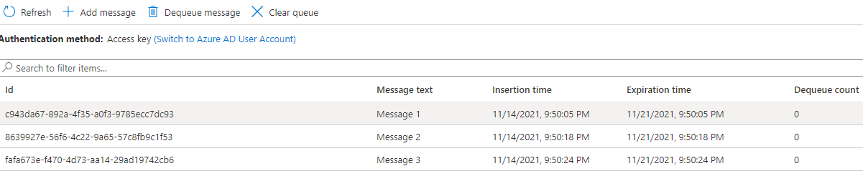

Note in the queue

* The messages are added / dequeued from the queue programmatically.

#### EXAMPLE

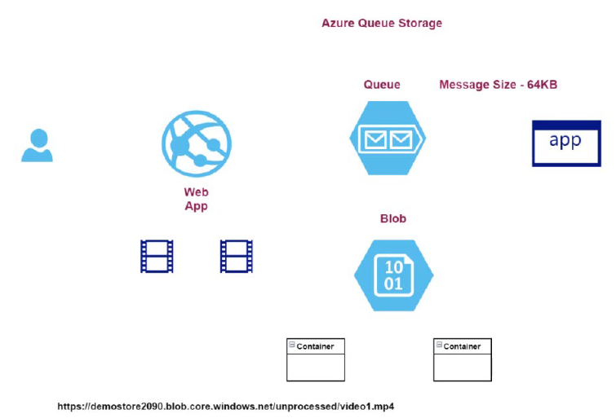

### AZURE COSMOS DATABASE

* This is a fully managed NoSQL database.
* The database provides fast response time and is highly scalable.
* Here the underlying infrastructure is completely managed by Azure.
* Commonly used for web, mobile, gaming and IoT applications that need to handle massive amounts of data.
* Azure Cosmos DB is a globally distributed, multi-model database service.
* You can elastically and independently scale throughput and storage across any number of Azure regions worldwide.
* Azure Cosmos DB supports schemaless data, which lets you build highly responsive and "Always On" applications to support constantly changing data.
* You can use this feature to store data that's updated and maintained by users around the world.

|  |  |
| --- | --- |
| **COSMOS DB** | **SQL DB** |
| We need to have relationship between tables | No SQL data store |
| When we you want to have constraints like foreign key constraint | Flexible Schema  No need of joins between data structures. |

#### COSMOS DB API

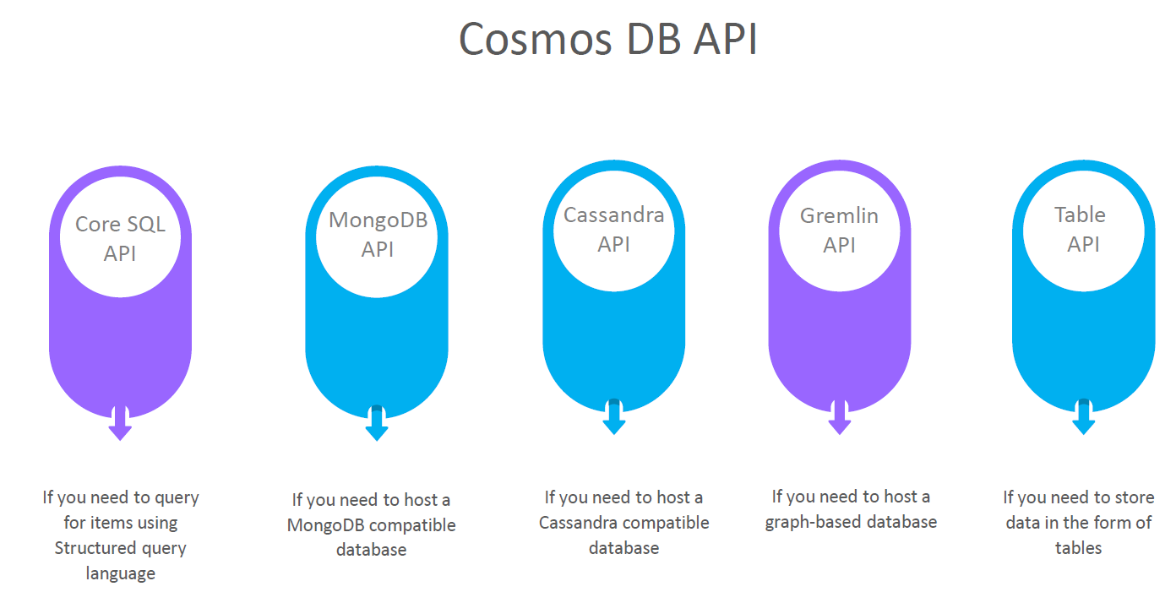

### CREATING A COSMOS DB ACCOUNT

#### SELECTING COSMOS DB API

1. We want to host a Data where we can issue SQL based command 🡪 Select Core(SQL) API.
2. All the data is stored in form of JSON when it comes to underlying document.

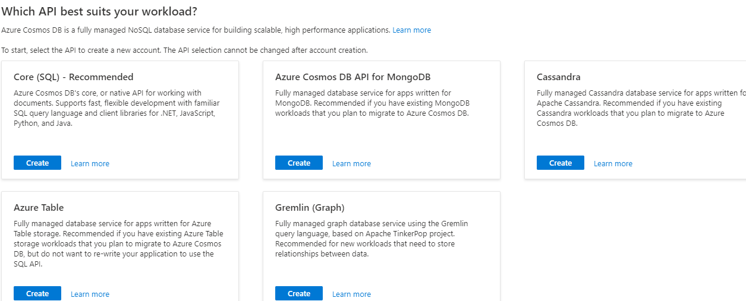

#### COSMOS DB ACCOUNT CONFIGURATION

|  |  |
| --- | --- |
|  | 1. When it comes to costing of the cosmos Db account it can be    1. Provisioned throughput    2. Serverless   PROVISION THROUGHOUT:  In this case, we are not charged separately for CPU , Memory etc. but we are charged based on RU(request unit) which is kind bundle of CPU , memory etc.. |

#### CREATING A COSMOS DATABASE AND CONTAINER

* Go to Data explorer 🡪 New Container

|  |  |
| --- | --- |
|  | * Step 1: We need to create a database * Step 2: The database contains container. Each database can have multiple containers. Container is equivalent to table in relational DB * Step 3: Container can have items. Item is equivalent to one record in relational DB   **CREATED DB AND CONTAINER** |

#### CREATING A COSMOS DATABASE AND CONTAINER

|  |  |
| --- | --- |
|  | * To add new items in the container 🡪 New Items   DATA FORMAT  {  "customerid":"C1",  "customername":"UserA",  "customercity":"Chicago"  } |

#### QUERYING CONTAINER DATA

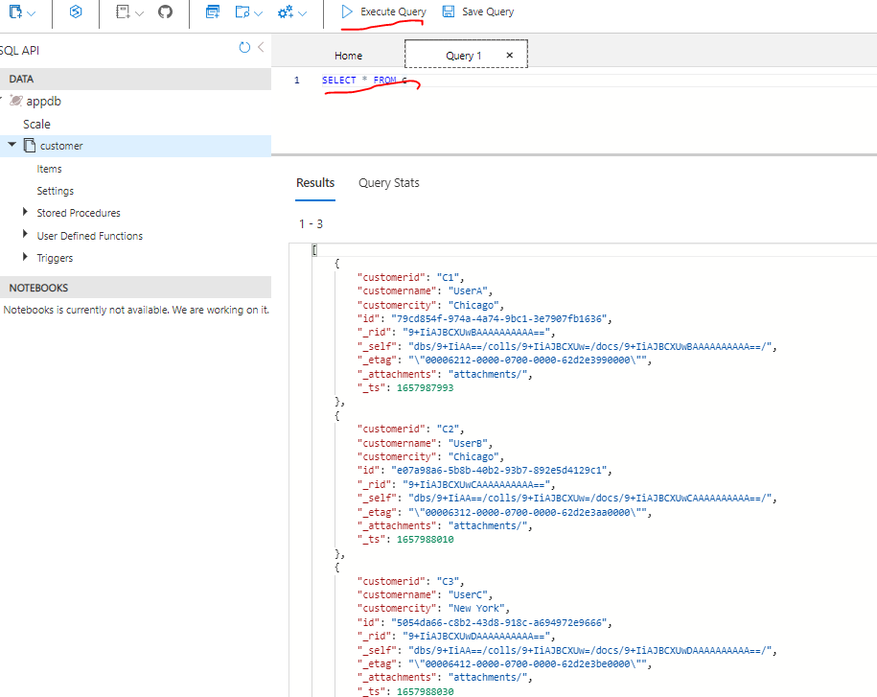

### AZURE SQL DATABASE

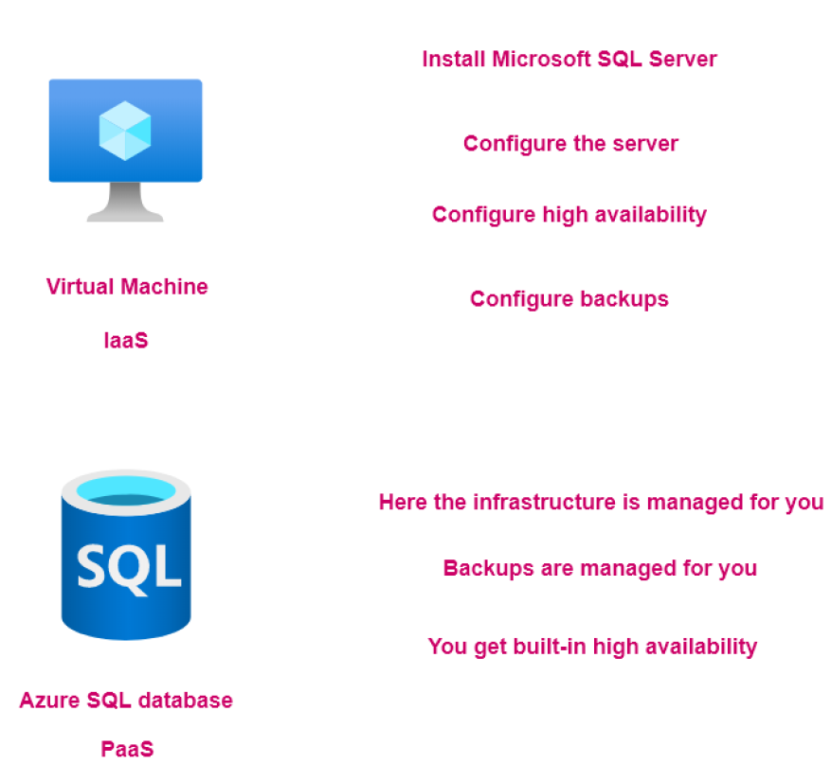

#### CREATING A SQL DATABASE SERVER

* When we use SQL Database service – it creates two resources
  + Azure SQL Database Server : This is managed by Azure itself. That’s the Azure SQL database is know has PaaS(Platform as a Service)
  + Azure SQL Database: To host the tables of data

STEP 1: CREATE THE SQL DATABASE

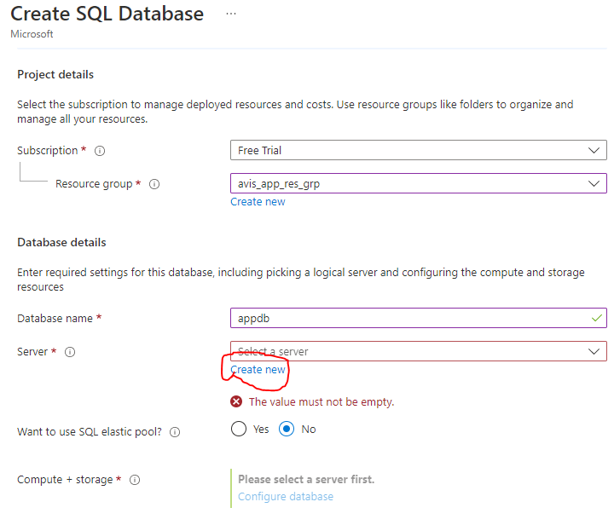

STEP 2: CREATE THE SQL DATABASE SERVER

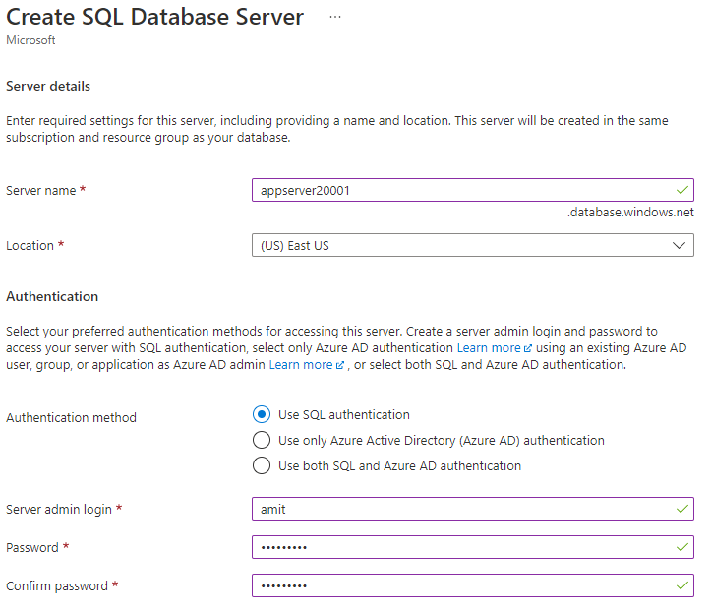

STEP 3: CONFIGURING THE SQL DATABASE (COMPUTE AND STOARAGE CONFIGURATION)

SQL database service pricing tier are classified in two broad categories:

**DTU –DATABASE TRANSACTION UNITS.**

* This is a blended measure of CPU, Memory and Input/Output.
* There are different pricing tiers when it comes to the DTU model.

**VCORE-BASED PURCHASING MODEL.**

* Here you can independently scale compute and storage.
* You can make use of the hybrid benefit model. Here you can save on costs if you have existing SQL Server licenses.

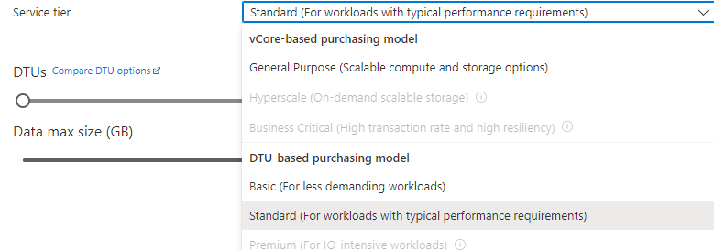

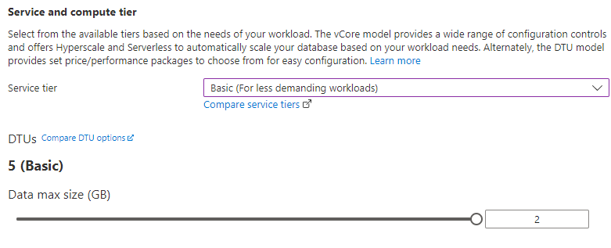

NETWORKING

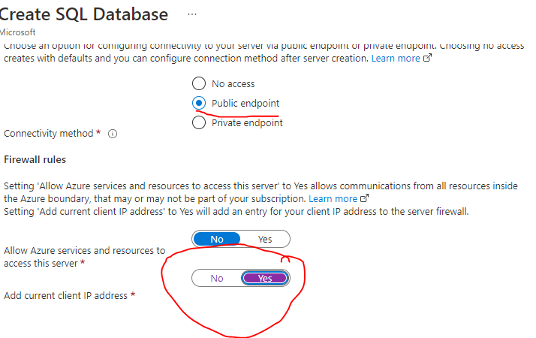

## AZURE WEB-APP SERVICE

* This is an HTTP-based service used for hosting web applications.
* The applications can be in .NET, .NET Core, Java, Ruby, Node.js or Python.
* Applications can run both on Windows or Linux-based platforms.
* This is a platform-as-a-service where the infrastructure is managed for us. Bu azure

***Note: These apps can also be hosted on VM, but this will be infrastructure as service. Here we must maintain the underlying VM on our own. For example – to host node-based app – it will be our job to install Node on the VM. We use this strategy when we need to deploy vendor-based application like AEM***

* Now in this platform has a service, the application gets deployed on an underlying virtual machine or an underlying compute infrastructure. Now, this entire infrastructure is managed by Azure themselves i.e., by the Azure App Service. Here we don't have to manage the underlying infrastructure like the underlying web server or underlying configuration of that web server. All of this is matched by the Azure App Service itself.

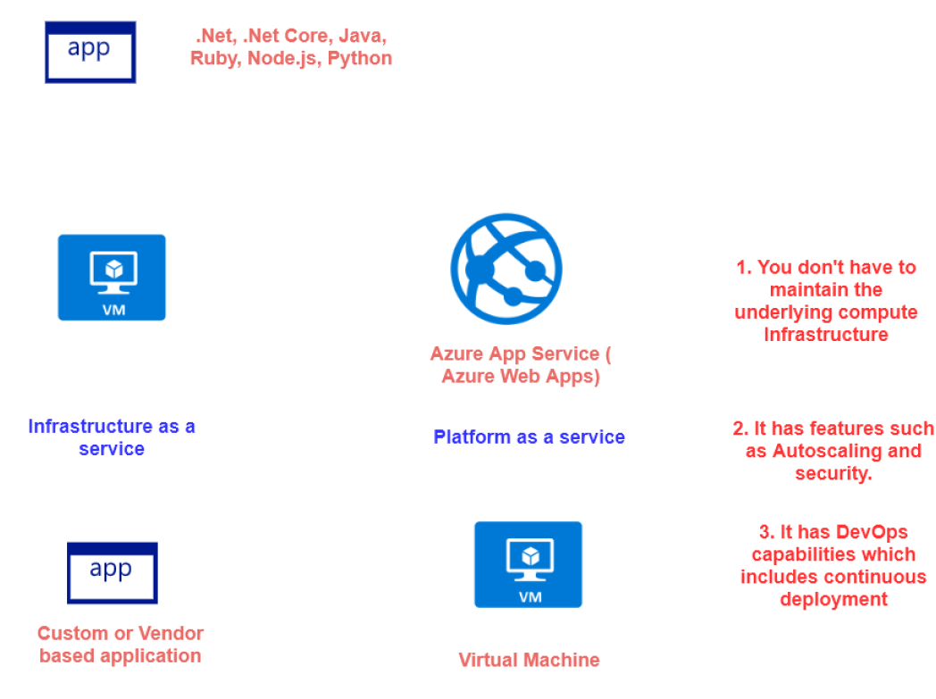

### ADVANTAGE OF USING APP SERVICE

* We don’t have to manage the underlying compute infrastructure.
* Features such as auto scaling and security,
* It also has DevOps capabilities.

### CREATING AN APP SERVICE

* Select “web App” service from the Create Resource

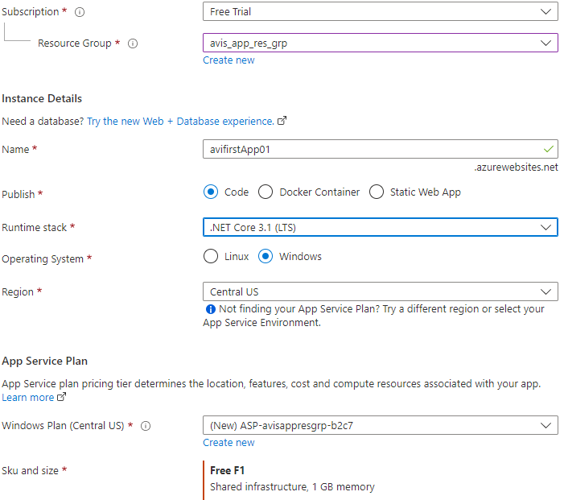

|  |  |
| --- | --- |
| Name | Unique name of the app. By default, azure append a default DNS name to the web app. We can have custom DNS name as well. |
| Publish | Type of App |
| Runtime Stack | Runtime of the of application is going to be hosted |

Once the setup is done. Azure will host a default “.NET Core” based application on Azure webapp service . For our case it can be accessed at - <https://avifirstapp01.azurewebsites.net/>

### AZURE APP SERVICE PLAN

* App service plan defines the set of compute resources that are used to run the web application

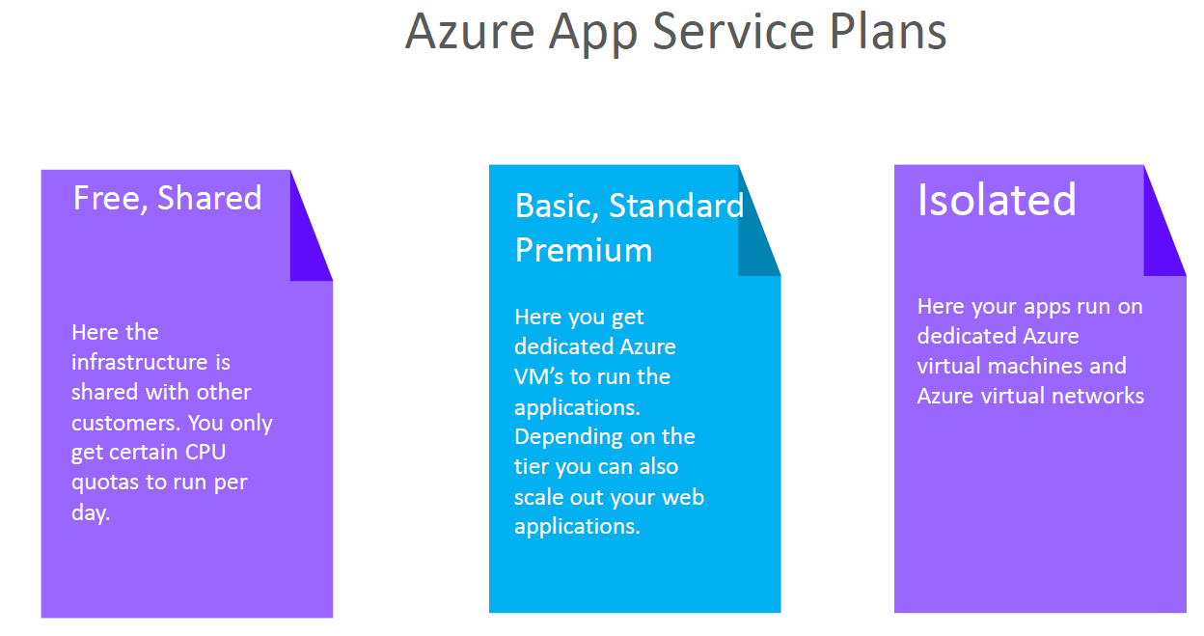

## VIRTUAL MACHINE SCALE SET

* Let's say we have hosting an application or you have some sort of workload that needs to be hosted on a virtual machine.
* Now, let's say that the application has a whole load of users that are hitting the application and it's putting a load, a high load on the virtual machine.
* Now you can change the size of the virtual machine. So initially, let's say it's a full virtual CPU.So you can scale up this machine on to, let's say an eight virtual CPU, but there is a limit on how much you can scale. And sometimes your application might not behave properly just by increasing the number of virtual CPUs or the memory.
* In this case, what you have to do is you need to ensure that you increase or scale the number of machines so that your application can be hosted on each machine.So when multiple users are now hitting your application, it can be distributed across the virtual machines.
* **Virtual machine skill set so this service can be used to scale the number of machines. This is different** from

distributing the traffic across the machines. That is done by another service that is known as the load balancer.

* Hence using VM scale set service we can provision based on demand identical virtual machines.
* So initially, we can have one machine that has been created by the virtual machine scale set. Then we can define rules, you can have a condition and the rules saying that please scale out if the CPU percentage goes beyond, let's say 70%. If it goes beyond 70%, then add one more machine. So if it goes beyond 70%, it will increase or, you know, scale up one more machine and now we'll have two machines as part of your infrastructure.
* **Note : We have to ensure that your application is installed on both machines. This is not going to be done automatically by the scale set service.**

### SCALLING IN VM SCALE SET

1. At peak demand /load. We can have three machines that have been spun up. If we have three machines, we are billed for all three machines
2. But now the demand of the application has become less. According to the scale set rule(scaling policy) on scale set it will be scaled down, let’s say 1 VM – Then we will be charged for just for 1 VM.

### CREATING A VM SCALE SET

## AZURE LOAD BALANCER

* This service is used to distribute the incoming network traffic across a group of backend resources of servers
* You can define two types of load balancers –***Public or Private Load Balancers***
* You have 2 SKUs for the Load Balancer –Standard and Basic Load Balancer

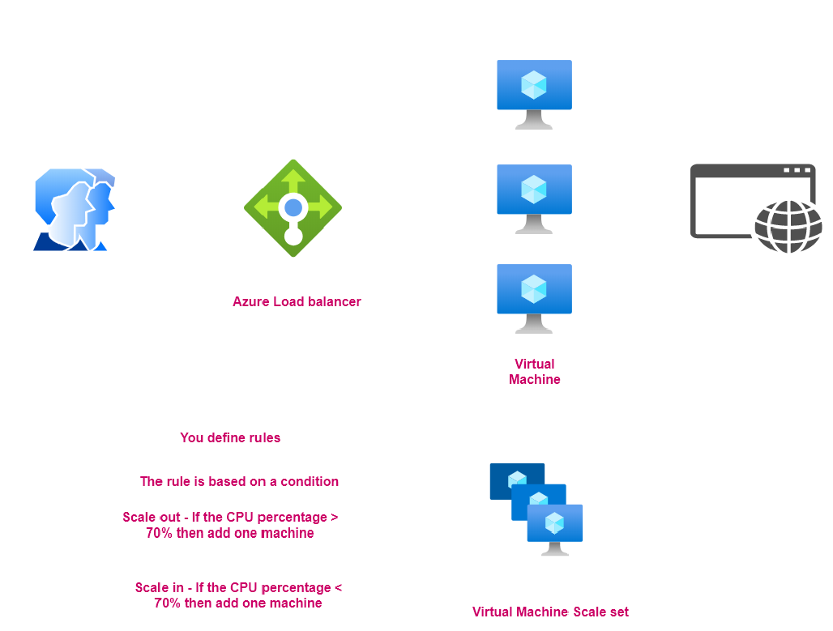

### COMPONENTS OF LOAD BALANCER

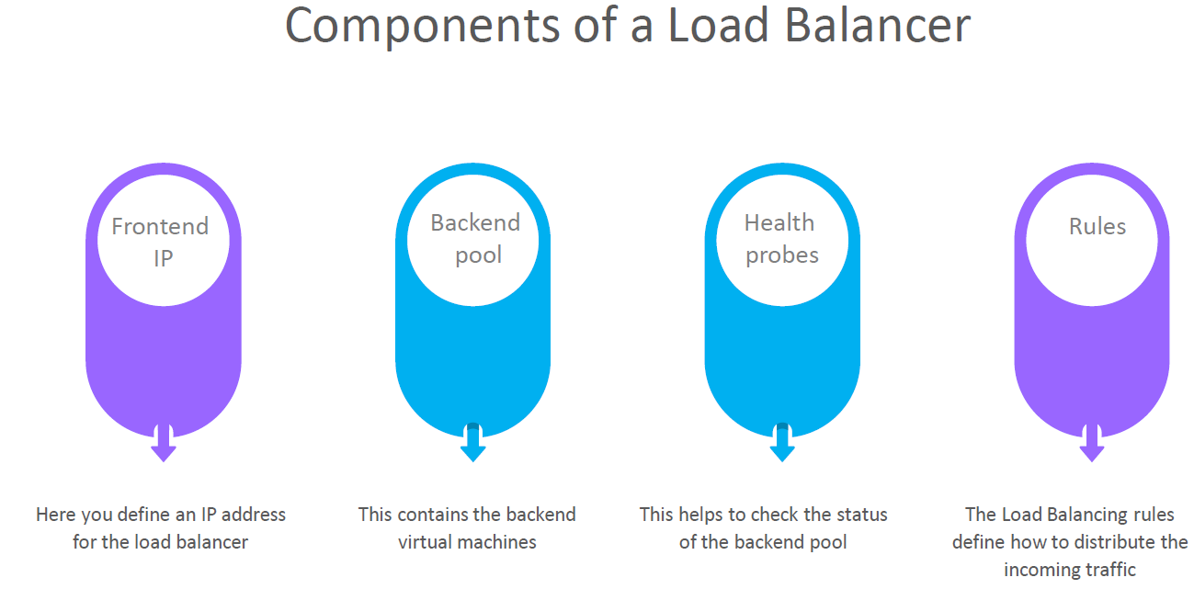

### BASIC LOAD BALANCER

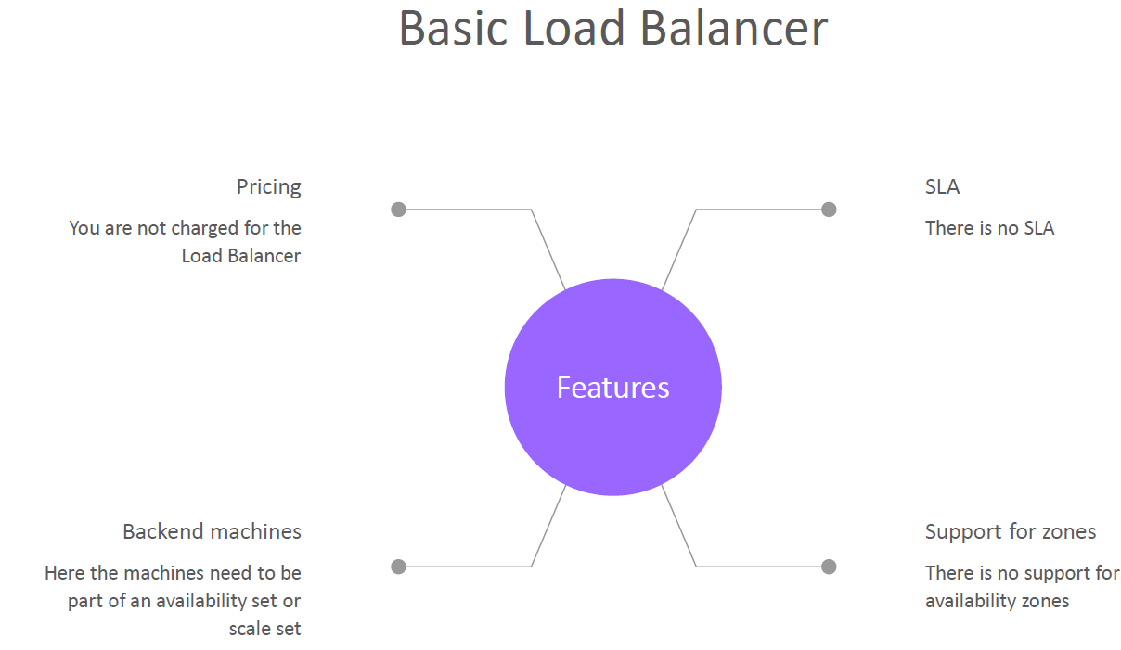

### STANDARD LOAD BALANCER

